BITS Pilani Hyderabad Campus

Submitted in fulfilment of project as part of the course

FIN F414 – Financial Risk Analytics and Management

**Time Series Forecasting of BATAINDIA and BERGEPAINT**

|  |  |  |  |
| --- | --- | --- | --- |
| Sr. No. | Name | ID | CONTRIBUTED |
| 1 | ANAND GOUR CHINTALURI | 2019B5PS1496H | YES |
| 2 | SATWIK ARINDAM HOTA | 2019A4PS0516H | YES |
| 3 | AMARTYA | 2020B3A30571H | YES |

April 2022



# ACKNOWLEDGEMENT

*We would like to express our sincere gratitude to Prof. Nagaraju Thota, for giving us an opportunity to work under him for this assignment and taking his valuable time to provide us with the required guidance wherever required. The input provided by him was very useful for working this assignment. We would also like to thank him for providing us with the opportunity to apply our course knowledge on real-life data and make valuable interpretation from it. We are indebted for all the help and guidance throughout the course and this assignment.*

Contents

ACKNOWLEDGEMENT 2

1 BATAINDIA 5

1.1 About the company 5

1.1.1 Nature of business 5

1.1.2 Ownership category 5

1.1.3 How did it start? 6

1.1.4 Significance in the industry 6

1.1.5 Overall greatness of the company 6

1.2 Daily Returns Analysis 7

1.2.1 Estimating Beta using CAPM Model 7

1.2.2 Estimating AR and MA coefficients using ARIMA Model 9

1.2.3 Forecasting volatility using GARCH and EGARCH Models 14

1.3 Weekly Returns Analysis 19

1.3.1 Estimating Beta using CAPM Model 19

1.3.2 Estimating AR and MA coefficients using ARIMA Mode 20

1.3.3 Forecasting volatility using GARCH and EGARCH Models 25

1.4 Monthly Returns Analysis. 30

1.4.1 Estimating Beta using CAPM Model 30

1.4.2 Estimating AR and MA coefficients using ARIMA Model 31

1.4.3 Forecasting volatility using GARCH and EGARCH Models 35

1.5 Conclusion 39

2 BERGEPAINT 40

2.1 About the company 40

2.1.1 Nature of business 40

2.1.2 Ownership category 40

2.1.3 How did it start? 40

2.1.4 Significance in the industry 41

2.1.5 Overall greatness of the company 41

2.2 Daily Returns Analysis 42

2.2.1 Estimating Beta using CAPM Model 42

2.2.2 Estimating AR and MA coefficients using ARIMA Model 44

2.2.3 Forecasting volatility using GARCH and EGARCH Models 48

2.3 Weekly Returns Analysis 52

2.3.1 Estimating Beta using CAPM Model 52

2.3.2 Estimating AR and MA coefficients using ARIMA Model 54

2.3.3 Forecasting volatility using GARCH and EGARCH Models 58

2.4 Monthly Returns Analysis 62

2.4.1 Estimating Beta using CAPM Model 62

2.4.2 Estimating AR and MA coefficients using ARIMA Model 63

2.4.3 Forecasting volatility using GARCH and EGARCH Models 66

2.5 Conclusion 70

2.6 References 70

# BATAINDIA

## About the company

### Nature of business

Bata Corporation is a is a Czech multinational footwear and fashion accessory manufacturer and retailer, with headquarters in Lausanne, Switzerland.

### Ownership category

Bata used to be a private company, but went public in 1973 when it changed its name to Bata India Limited. 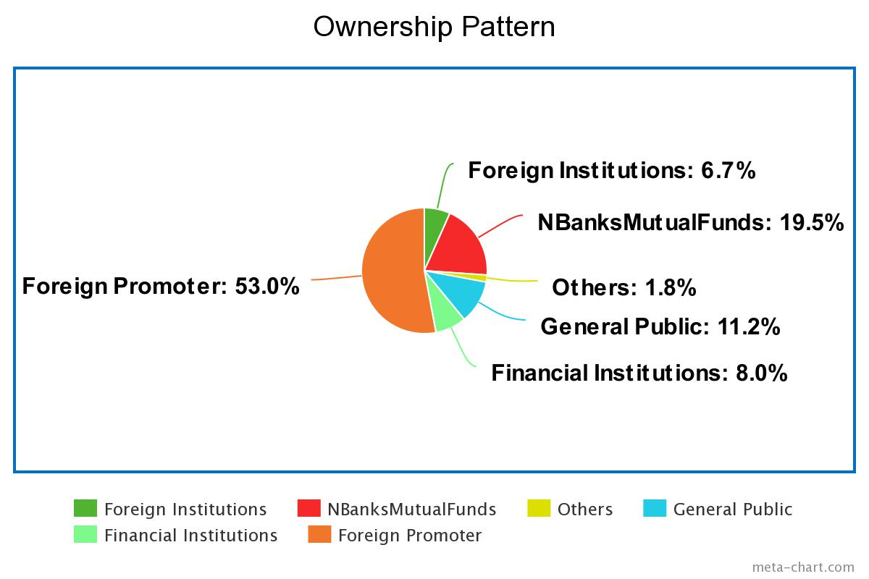

|  |  |  |
| --- | --- | --- |
| **Holder’s Name** | **No. of Shares** | **% of Share Holding** |
| Promoter’s | 0 | 0% |
| Foreign Institutions | 8560583 | 6.66% |
| NbanksMutualFunds | 25007598 | 19.46% |
| Others | 2320928 | 1.81% |
| General Public | 14353442 | 11.17% |
| Financial Institutions | 10219475 | 7.95% |
| Foreign Promoter | 68065514 | 52.96% |
| Total No. of Shares | 128527540 | 100% |

### How did it start?

The T. & A. Baťa Shoe Company was founded on 24 August 1894 in the Moravian town of Zlín, Austria-Hungary (today in the Czech Republic), by Tomáš Baťa, his brother Antonín and his sister Anna, whose family had been cobblers for generations. At the time the company employed 10 full-time employees with a fixed work schedule and a regular weekly wage.

Initial export sales and the first ever sales agencies began in Germany in 1909, followed by the Balkans and the Middle East. Baťa shoes were considered to be excellent quality, and were available in more styles than had ever been offered before.

Today as well Bata corporation is a family-owned business, the company is organized into three business units: Bata, Bata Industrials (safety shoes) and AW Lab (sports style).

### Significance in the industry

Bata estimates that it serves more than 1 million customers per day, employing over 30,000 people, operates more than 5,300 shops, manages 23 production facilities and a retail presence in over 70 countries across the five continents. Bata has a strong presence in countries including India where it has been present since 1931. It has established itself as India's largest footwear retailer.

### Overall greatness of the company

Bata’s culture is rooted in what it stands for. The company’s success has been built through the values they believe in. Every achievement, every accomplishment, every step forward was powered by the same engine: our core values.

Improving lives, being bold, exceeding customer expectations, serving with passion, counting on each other are the core values of Bata.

## Daily Returns Analysis

### Estimating Beta using CAPM Model

The CAPM model can be written as

E(R) = Rf + Beta*(Rm-Rf)

Where

● E(R) is the expected return of the firm

● Rf is the risk-free rate

● Rm is the returns of the market

Beta is obtained from running a linear regression between security returns as the dependent variable and market returns as the independent variable. The slope of the regression is termed as beta of the security. It tells us how sensitive the security returns are with respect to change in market returns.

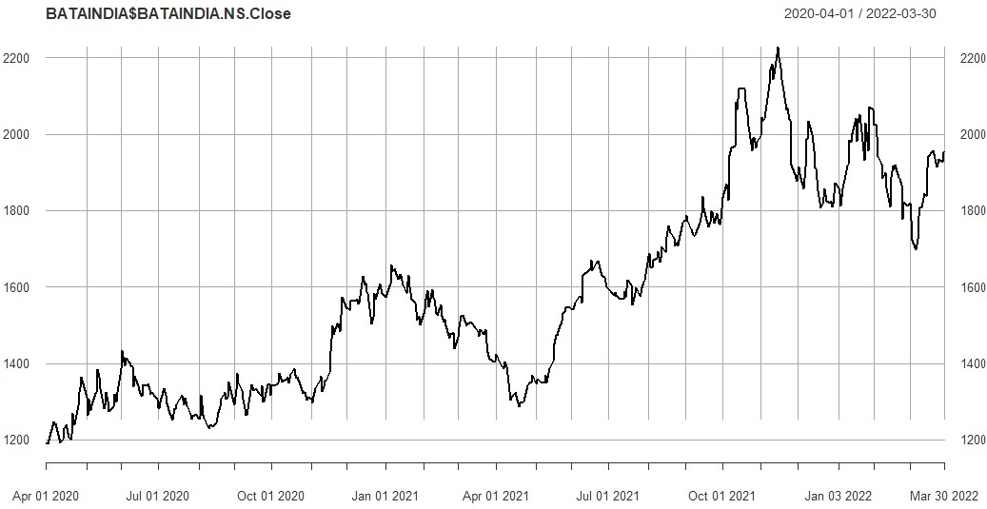Returns of the security were calculated on a daily basis from 1st April 2020 to 31st March 2022. The closing prices of the security for the period of analysis have been plotted below and excess returns were calculated for the security as well as the index based on the closing prices.

figure 1.1: Daily Closing Price of BATA vs Date

Returns of the security were plotted for the analysis period and there was no specific pattern observed. It was random walk or a white noise process return with the returns oscillating between -5% to +5% for the analysis with a few outliers in between which reached -6% and +6% at most.

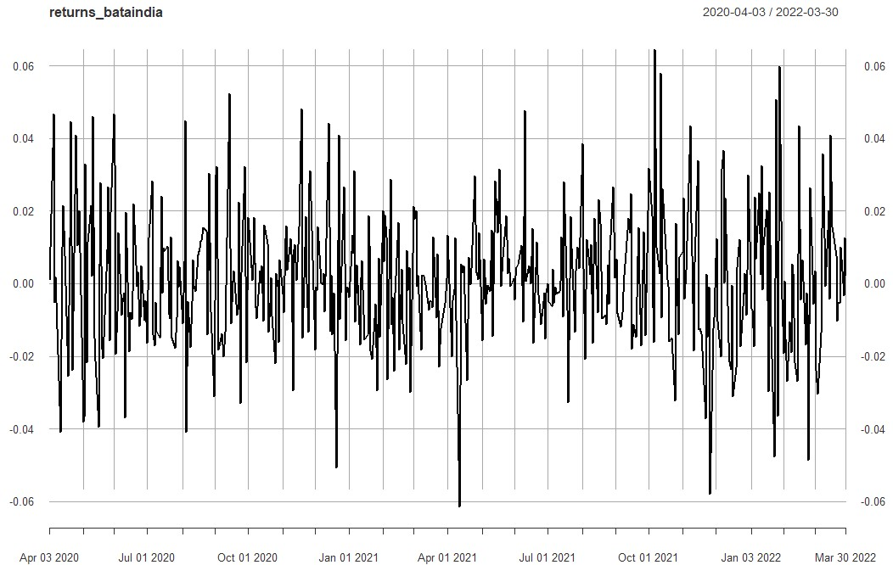

figure 1.2: Daily Returns of BATA vs Date

A linear regression was done between the excess security returns as the dependent variable and excess market returns as the independent variable and the following results were obtained.

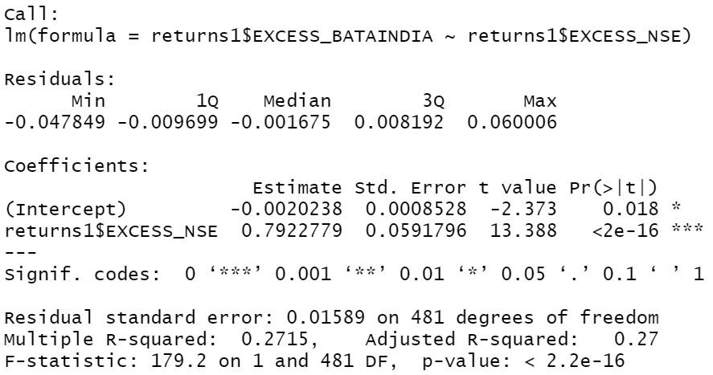Figure 1.3: Results of Linear Regression for Daily Returns of BATA

Slope of the regression was found to be 0.7922779 (approx.=0.79) and the intercept was 0.0020238. The p-value of the slope is less than 0.05 signifying that the slope is significant on a 95% confidence interval.

**Economic Interpretation:** Beta of the regression was found out to be 0.79 which indicates that the security is less sensitive to changes in macroeconomic factors than the market. For a change of 1% in market return the security return will change by 0.79%.

### Estimating AR and MA coefficients using ARIMA Model

For ARIMA models, a standard notation would be ARIMA with p, d, and q, where integer values substitute for the parameters to indicate the type of ARIMA model used. The parameters can be defined as:

1. **p**: The number of lag observations in the model; also known as the lag order.

2. **d**: the number of times that the raw observations are differenced; also known as the degree of differencing.

3. **q**: the size of the moving average window; also known as the order of the moving average.

In simple words the order of AR which comes from PACF correlogram gives the value of p, count of differentiation gives the value of d, the order of MA which comes from ACF correlogram gives the value of q.

The AR and MA coefficient of the security can be estimated by running the ACF and PACF plots.

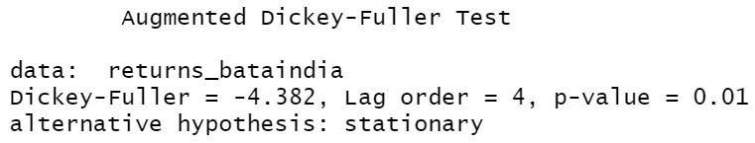For checking the stationarity of return series, we conducted an Augmented Dickey-Fuller. Results of the tests were as follows.

Figure 1.4: Augmented Dickey-Fuller Test for Daily Returns of BATA

The p-value from Augmented Dickey-Fuller Test is less than 0.05 which signifies that the series is stationary as we are rejecting the null hypothesis.

The series is found to be (weakly) stationary so it will satisfy the following properties:

● The mean E(yt) is the same for all t.

● The variance of yt is the same for all t.

● The covariance (and also correlation) between yt and yt-1 is the same for all t.

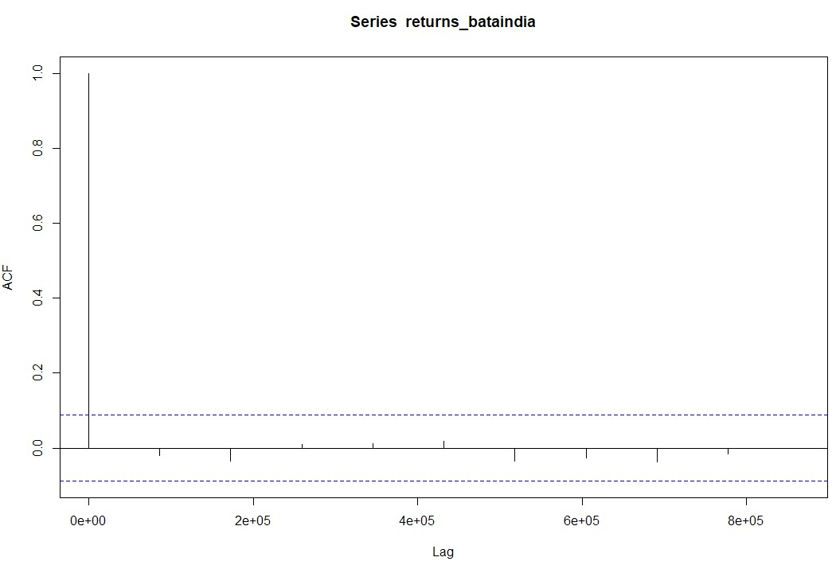**ACF plot:**

Figure 1.5: ACF Plot for Daily Returns of BATA

The ACF property defines a distinct pattern for the autocorrelations. For a positive value of ϕ1, the ACF exponentially decreases to 0 as the lag h increases. For negative ϕ1, the 10 ACF also exponentially decays to 0 as the lag increases, but the algebraic signs for the autocorrelations alternate between positive and negative.

Since, the ACF is not significant for any value of lag, the order of the moving average model is zero. It is estimated to be a MA (0) model.

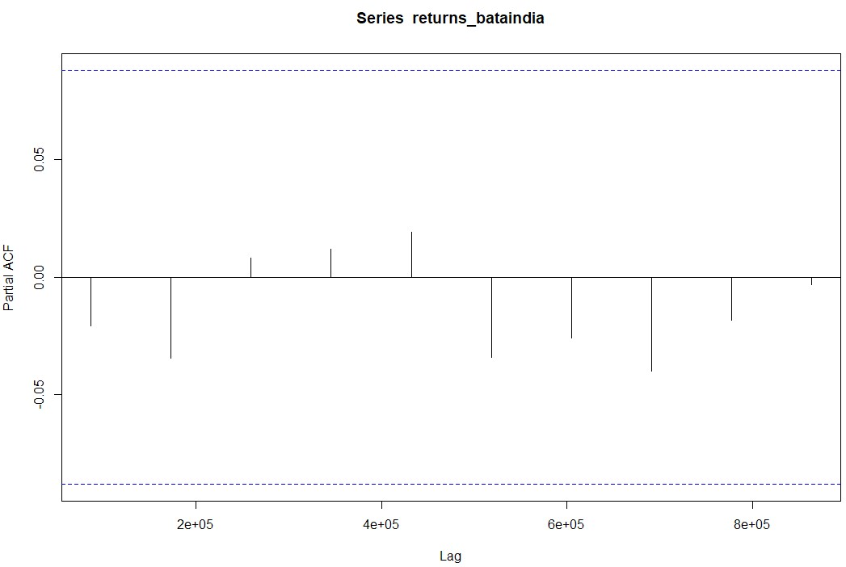**PACF plot:**

Figure 1.6: PACF Plot for Daily Returns of BATA

Autocorrelation for all the lags are statistically unsignificant. This suggests a possible AR (0) model for these data. As can be seen from the graph above that the PACF is not significant for any value of lag, the order of the auto regressive model can be taken as zero.

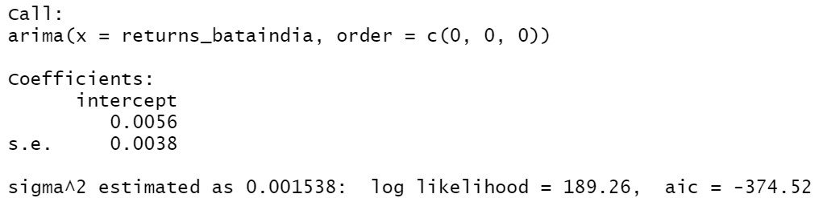After this, we run the ARIMA model on all orders (p,d,q) which we think might make a good model and choose the best amongst them. The best model is that which have the least AIC value. Using the ARIMA model, we predict the values for a small period of time and assess the model finally.

Figure 1.7: ARIMA Model Test for Daily Returns of BATA

After running various (p,d,q) models we see that the least value of AIC is for the (0,0,0) which is what we estimated from ACF and PACF models.

**Diagnostic test:**

Figure 8: Diagnostic Model Test for Daily Returns of BATA

Interpretation:

● Standardized Residuals of the model are randomly distributed.

● ACF of residuals is not significant for any value lag.

● The p-values for Ljung-Box is always greater than 0.05.

Therefore, we can conclude on the basis of above three observations that the model is a good fit.

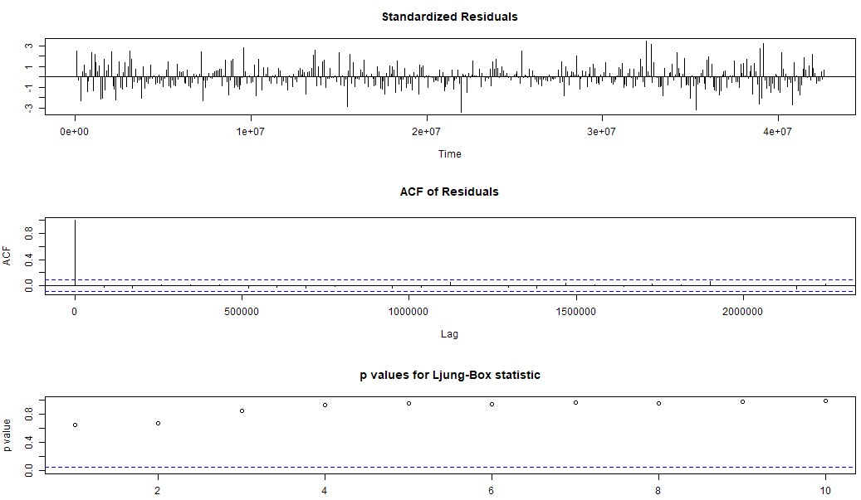

Figure 1.8: Diagnostic Model Test for Daily Returns of BATA

**Prediction using the ARIMA model:**

The ARIMA Model was used to predict the return after the analysis period which end on 31 March, 2022. The forecast given by the model is given below.

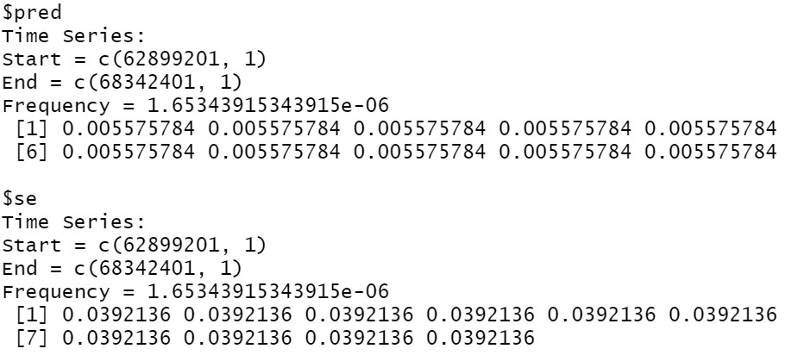Figure 1.9: Forecasted Returns of BATA using ARIMA Model

### Forecasting volatility using GARCH and EGARCH Models

GARCH(Generalized Autoregressive Conditional Heteroskedasticity) is a volatility predicting model which works upon the concept of “Volatility Clustering” which implies that higher volatility is followed by higher volatility and same for the lower. The model works upon three equation “Mean eq., Volatility eq, Distribution eq.”

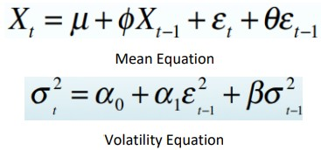

We run the GARCH model specs on the daily returns of BATA.

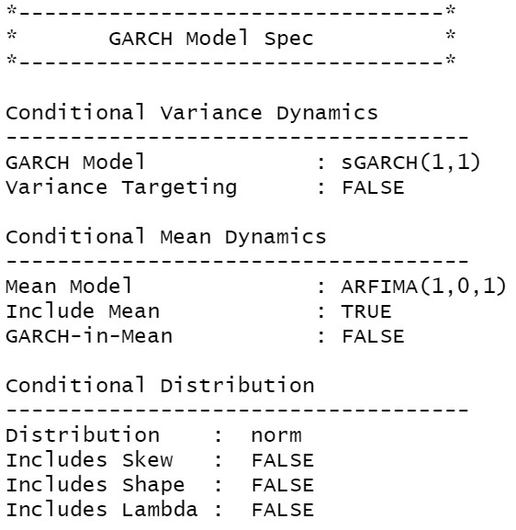

Figure 1.10: GARCH Specs for Daily Returns of BATA

From above table we see that GARCH (1,1) is the most appropriate model and by default the mean model ARFIMA(1,0,1) is chosen.

We run the EGARCH model specs again on the daily returns of BATA

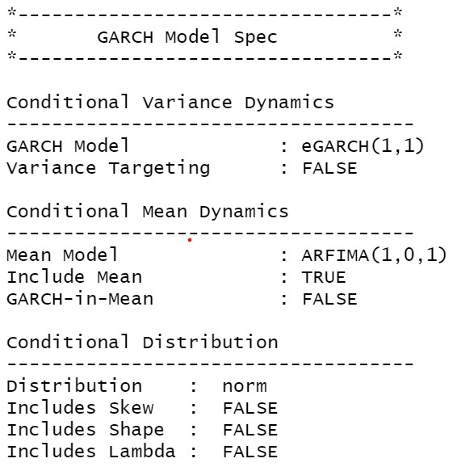

Figure 1.11: GARCH Specs for Daily Returns of BATA

From above table we see that EGARCH (1,1) is the most appropriate model and by default the mean model ARFIMA (1,0,1) is chosen. These results are similar to what we observed for GARCH model.

**Estimating the Model:**

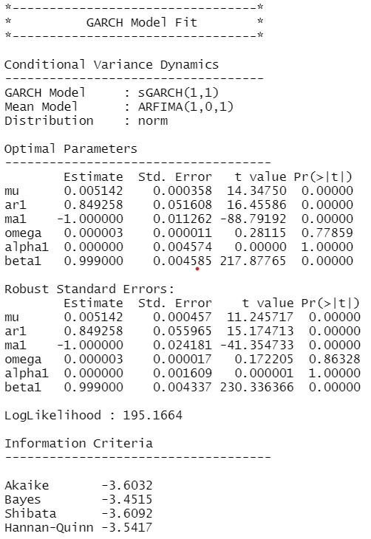

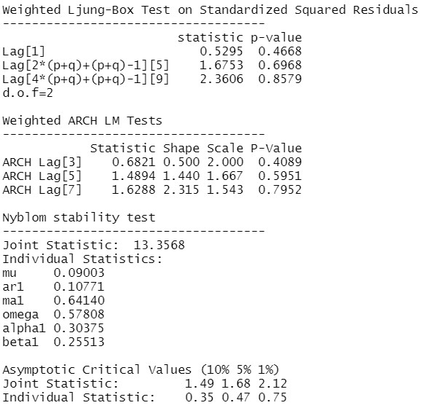

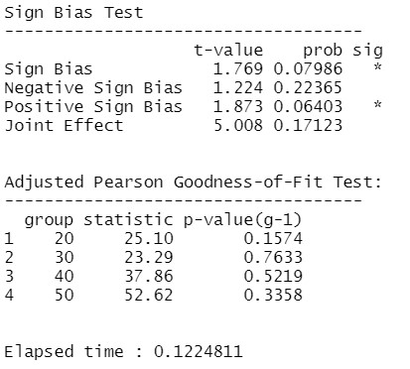

figure 1.12: Diagnostic Test of GARCH Model for Daily Returns of BATA

Interpretation:

● In GARCH, the variance tends to show mean reversion which means it gets pulled to a long-term volatility rate over time.

● Here Omega, Alpha and Beta obtained from estimated standard error are given in the figure above.

**GARCH Model Forecast:**

Now we use the GARCH Model to forecast volatility after 31st March, 2021. The forecast are as follows:

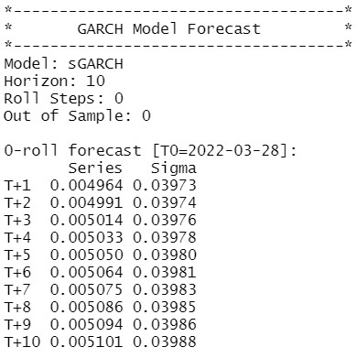

Figure 1.13: Forecasted Volatility of Daily Returns of BATA

## Weekly Returns Analysis

### Estimating Beta using CAPM Model

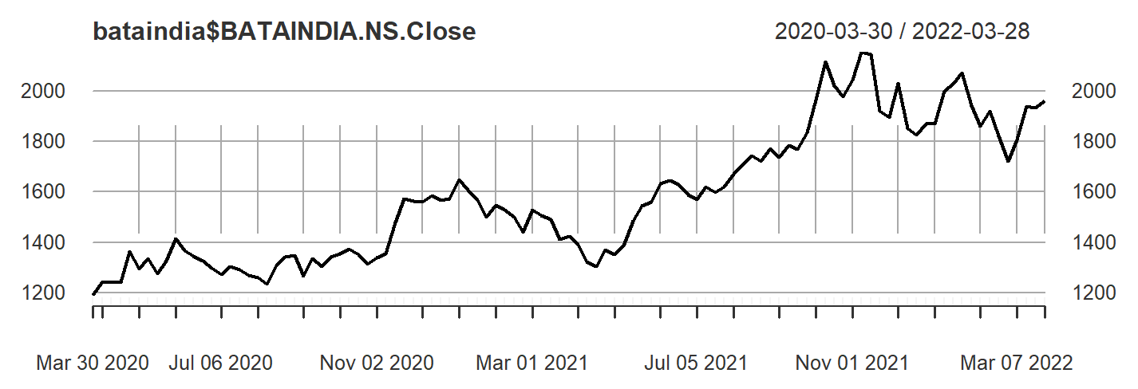

figure 1.14: Weekly Closing Price of BATA vs Date

From the above graph we can see that the weekly returns mainly fluctuate between -5% to 5% with outliers going between -10% to 10% with no specific pattern for the returns over the forecasted period.

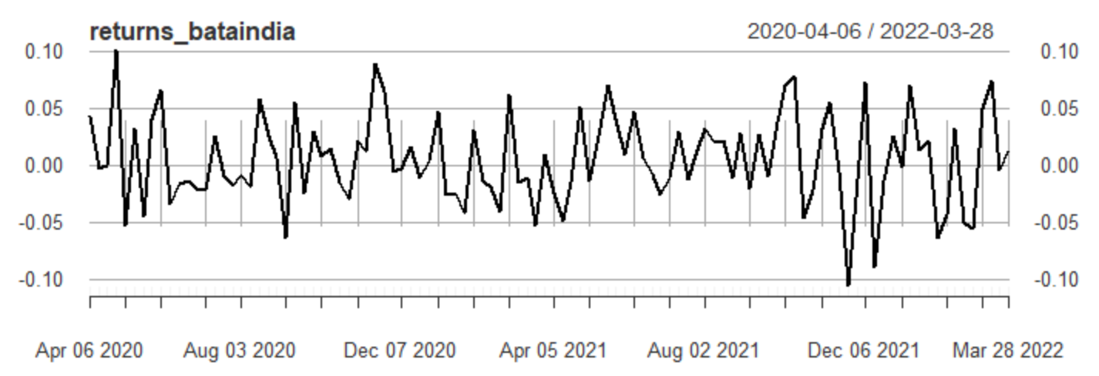

figure 1.15: Weekly Returns of BATA vs Date

The excess weekly returns are regressed as the dependent variable with the excess market returns as the independent variable.

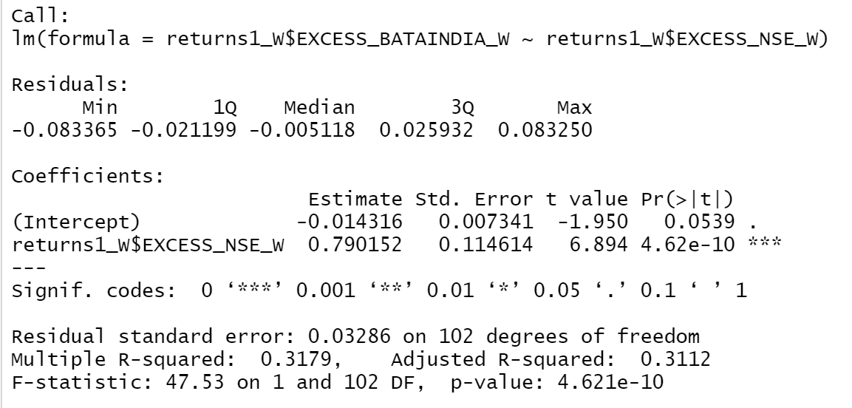

Figure 1.16: Results of Linear Regression for Daily Returns of BATA

Based on the results from the CAPM we can see that the slope of regressed line is 0.790152 with an intercept of 0.014316. The p value for the slope being less than 0.05 indicating that the regression has a confidence interval of 95%.

Economic Interpretation: Beta of the regression was found out to be 0.79 which indicates that the security is less sensitive to changes in macroeconomic factors than the market. For a change of 1% in market return the security return will change by 0.79%.

### Estimating AR and MA coefficients using ARIMA Mode



figure 1.17: Weekly Returns of BATA vs Date

The Augmented Dickey- Fuller Test was used for the stationary returns and these are the results.

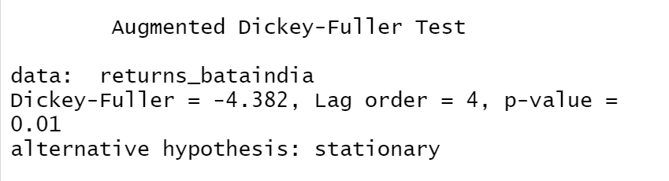

Figure 1.4: Augmented Dickey-Fuller Test for Weekly Returns of BATA

The p-value from Augmented Dickey-Fuller Test is less than 0.05 which signifies that the series is stationary as we are rejecting the null hypothesis.

The series is found to be (weakly) stationary so it will satisfy the following properties:

● The mean E(yt) is the same for all t.

● The variance of yt is the same for all t.

● The covariance (and also correlation) between yt and yt-1 is the same for all t.

**ACF Plot:**

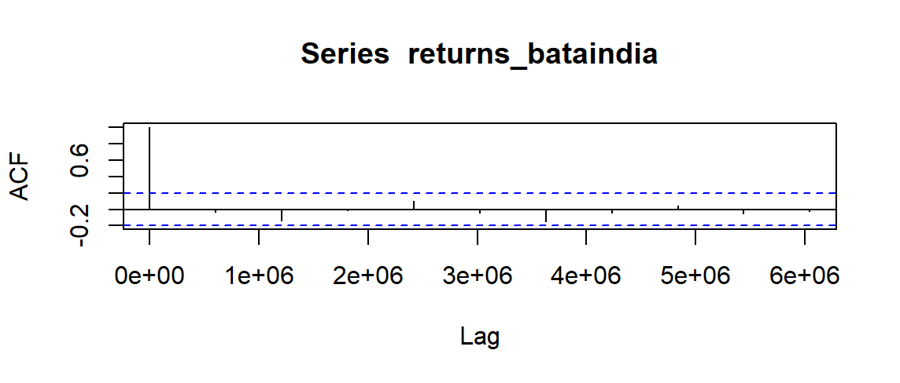

Figure 1.18: ACF Plot for Weekly Returns of BATA

The ACF property defines a distinct pattern for the autocorrelations. For a positive value of ϕ1, the ACF exponentially decreases to 0 as the lag h increases. For negative ϕ1, the 10 ACF also exponentially decays to 0 as the lag increases, but the algebraic signs for the autocorrelations alternate between positive and negative.

Since, the ACF is not significant for any value of lag, the order of the moving average model is zero. It is estimated to be a MA (0) model.

**PACF Plot:**

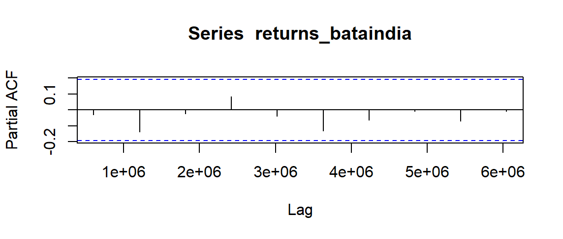

Figure 1.19: PACF Plot for Weekly Returns of BATA

Autocorrelation for all the lags is statistically insignificant. This suggests a possible AR (0) model for these data. As can be seen from the graph above that the PACF is not significant for any value of lag, the order of the auto regressive model can be taken as zero.

After this, we run the ARIMA model on all orders (p,d,q) which we think might make a good model and choose the best amongst them. The best model is that which have the least AIC value. Using the ARIMA model, we predict the values for a small period of time and assess the model finally.

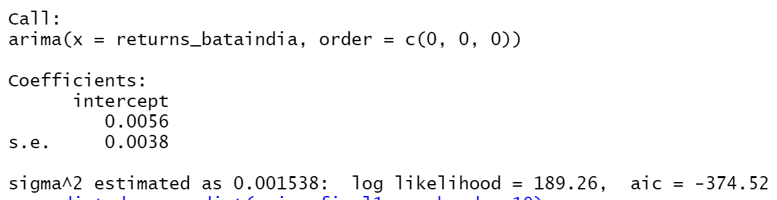

Figure 1.7: ARIMA Model Test for Weekly Returns of BATA

After running various (p,d,q) models we see that the least value of AIC is for the (0,0,0) which is what we estimated from ACF and PACF models.

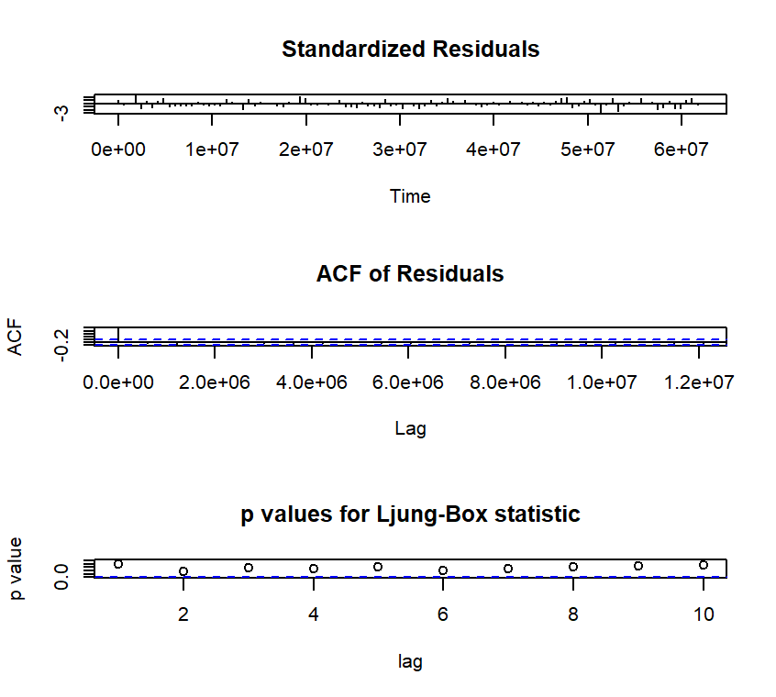Figure 20: Diagnostic Model Test for Daily Returns of BATA

**Interpretation**:

● Standardized Residuals of the model are randomly distributed.

● ACF of residuals is not significant for any value lag.

● The p-values for Ljung-Box is always greater than 0.05.

Therefore, we can conclude on the basis of above three observations that the model is a good fit.

**Prediction using the ARIMA model:**

The ARIMA Model was used to predict the return after the analysis period which end on 31 March, 2022. The forecast given by the model is given below.

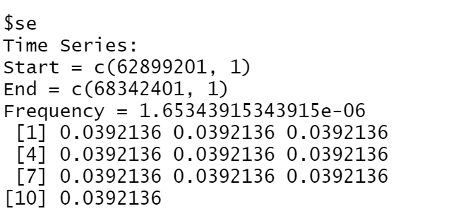

Figure 1.21: Forecasted Returns of BATA using ARIMA Model

### Forecasting volatility using GARCH and EGARCH Models

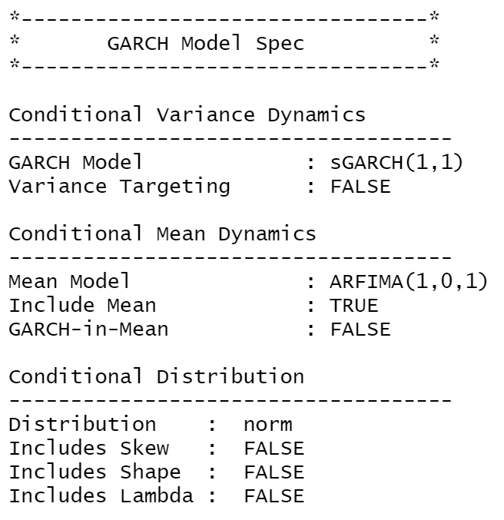

Figure 1.22: GARCH Specs for Weekly Returns of BATA

From above table we see that GARCH (1,1) is the most appropriate model and by default the mean model ARFIMA (1,0,1) is chosen

We run the EGARCH model specs again on the weekly returns of BATA

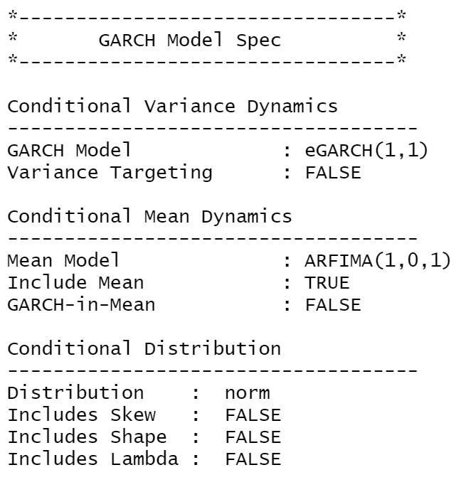

Figure 1.23: eGARCH Specs for Weekly Returns of BATA

From above table we see that EGARCH (1,1) is the most appropriate model and by default the mean model ARFIMA (1,0,1) is chosen. These results are similar to what we observed for GARCH model.

**Estimating the Model:**

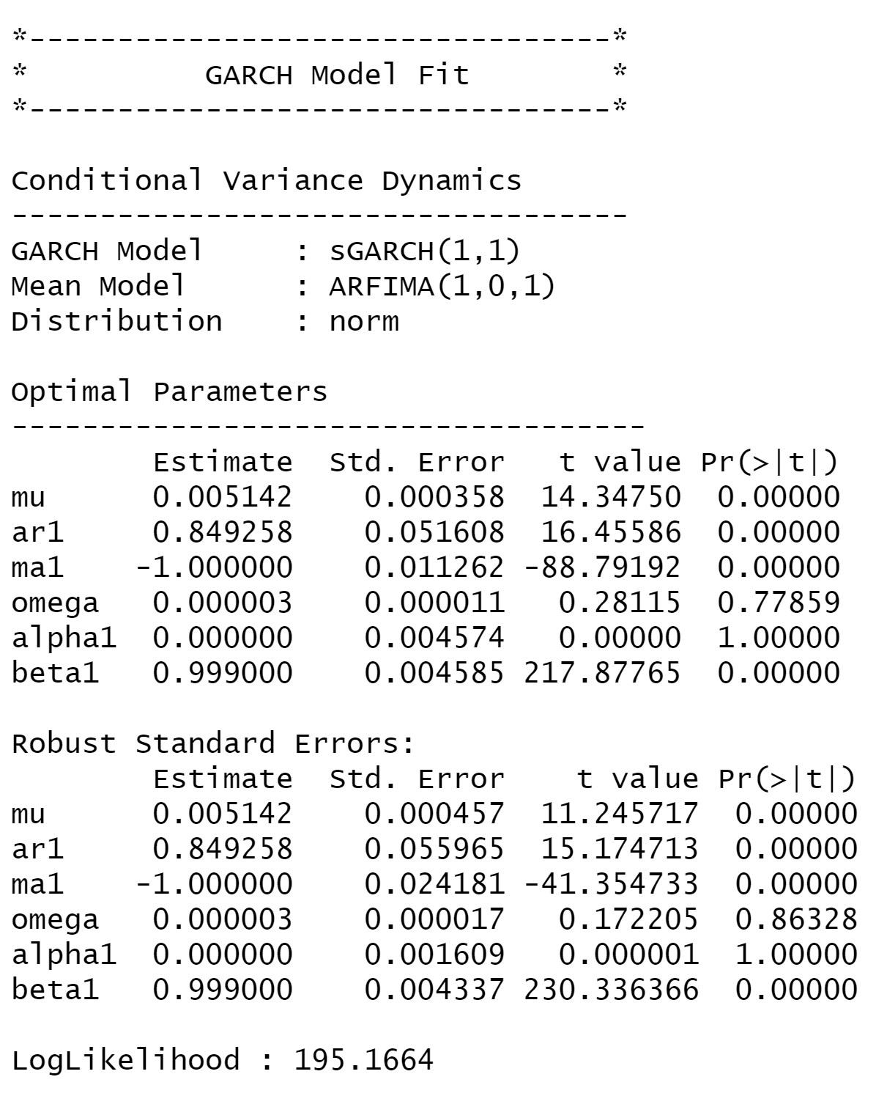

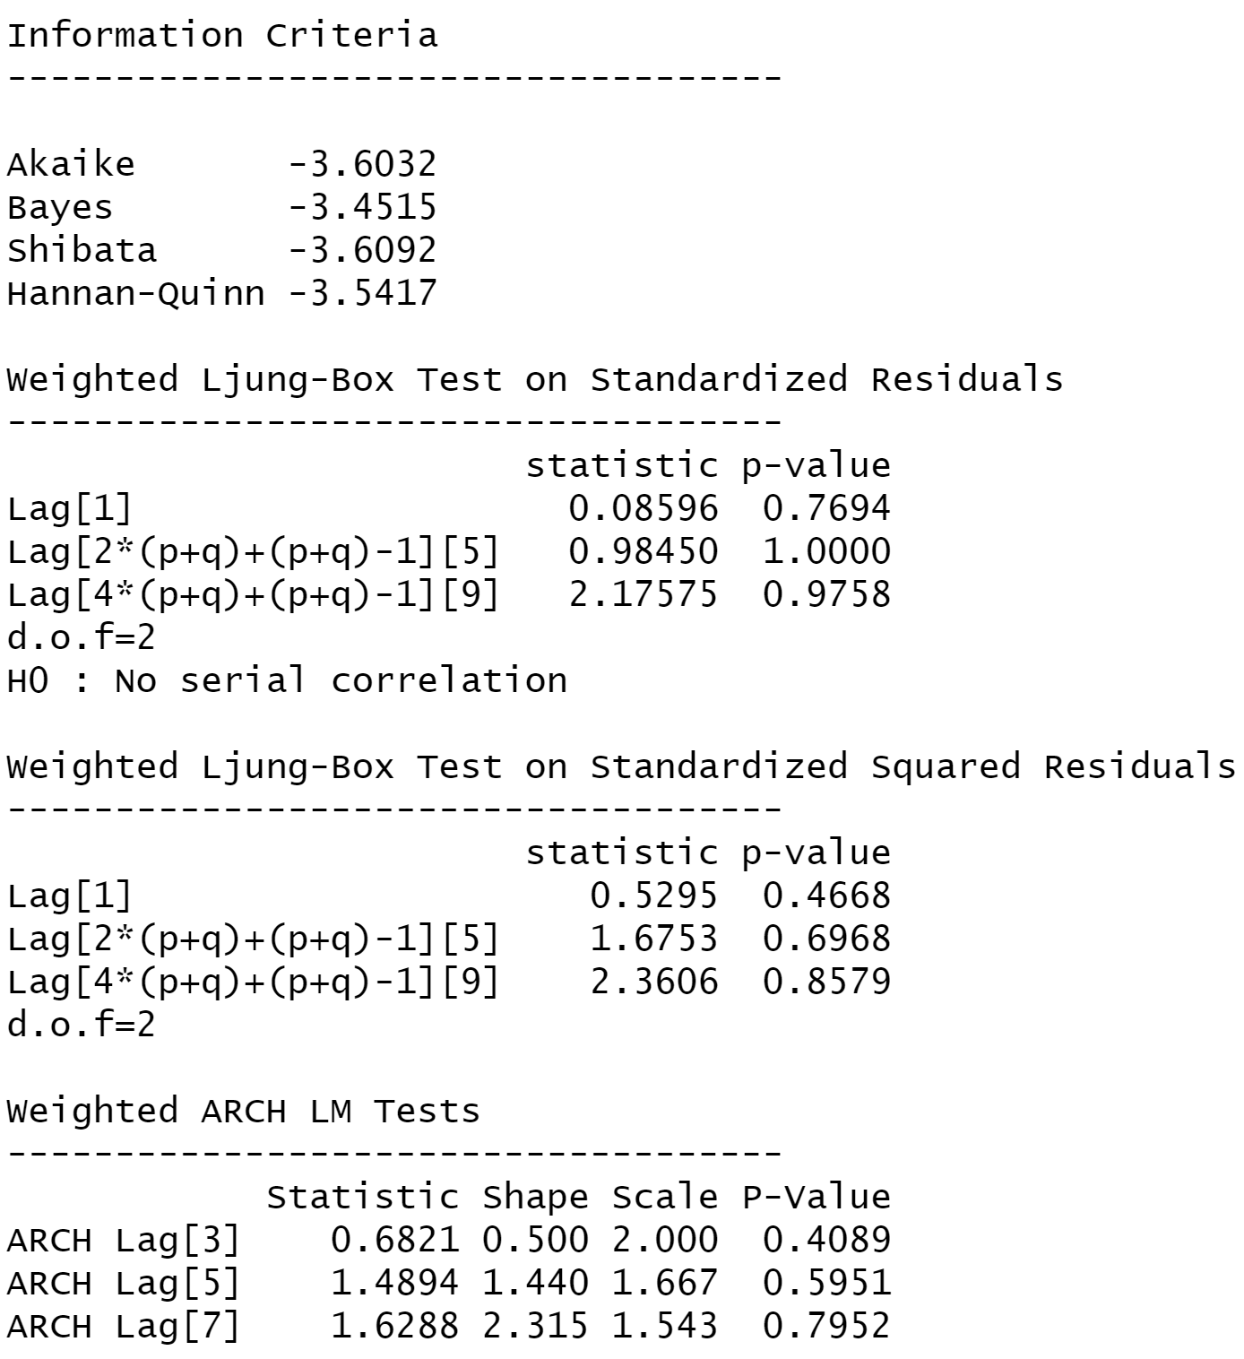

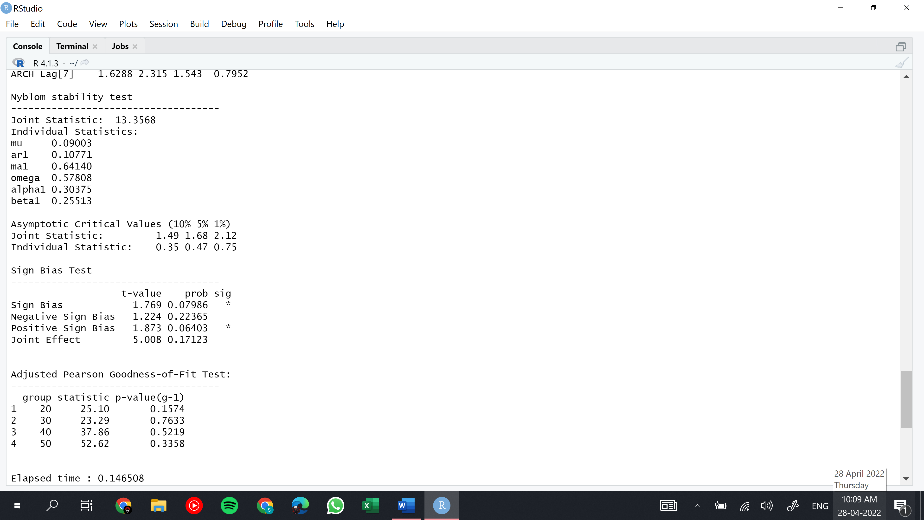

figure 1.24: Diagnostic Test of GARCH Model for Weekly Returns of BATA

Interpretation:

● In GARCH, the variance tends to show mean reversion which means it gets pulled to a long-term volatility rate over time.

● Here Omega, Alpha and Beta obtained from estimated standard error are given in the figure above.

**GARCH Model Forecast:**

Now we use the GARCH Model to forecast volatility after 31st March, 2021. The forecast are as follows:

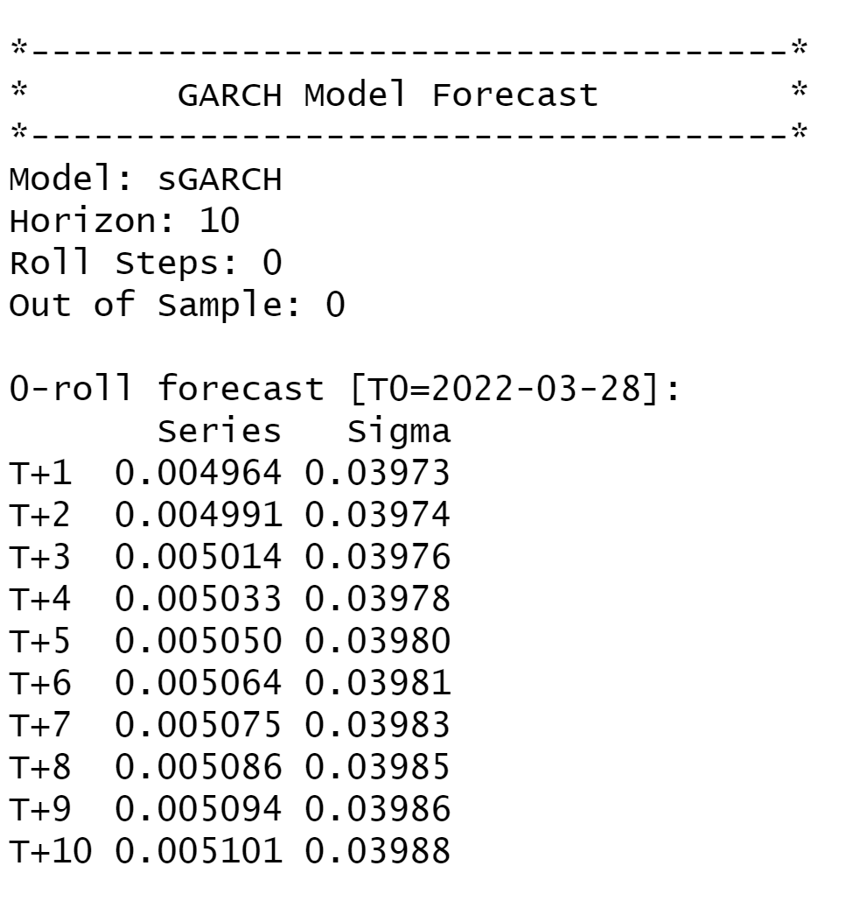

Figure 1.25: Forecasted Volatility of Weekly Returns of BATA

## Monthly Returns Analysis.

### Estimating Beta using CAPM Model

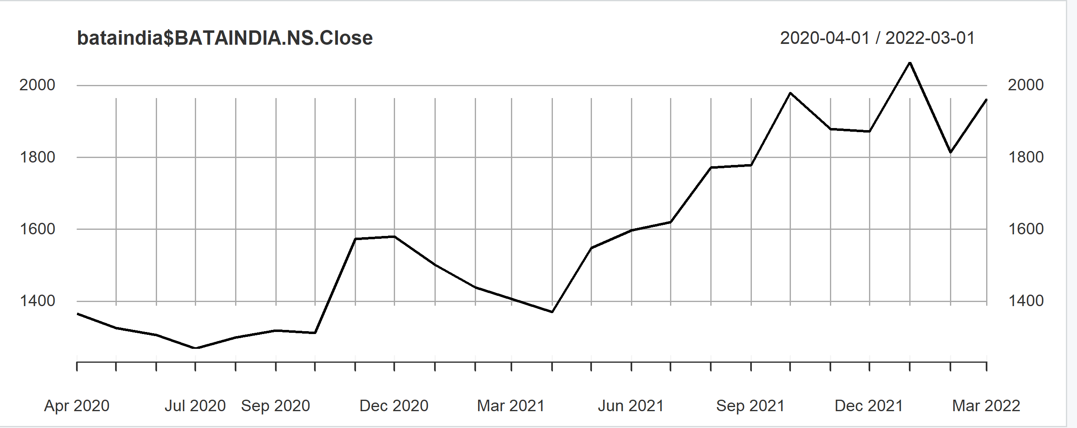

figure 1.26: Monthly Closing Price of BATA vs Date

The excess monthly returns are regressed as the dependent variable with the excess market returns as the independent variable.

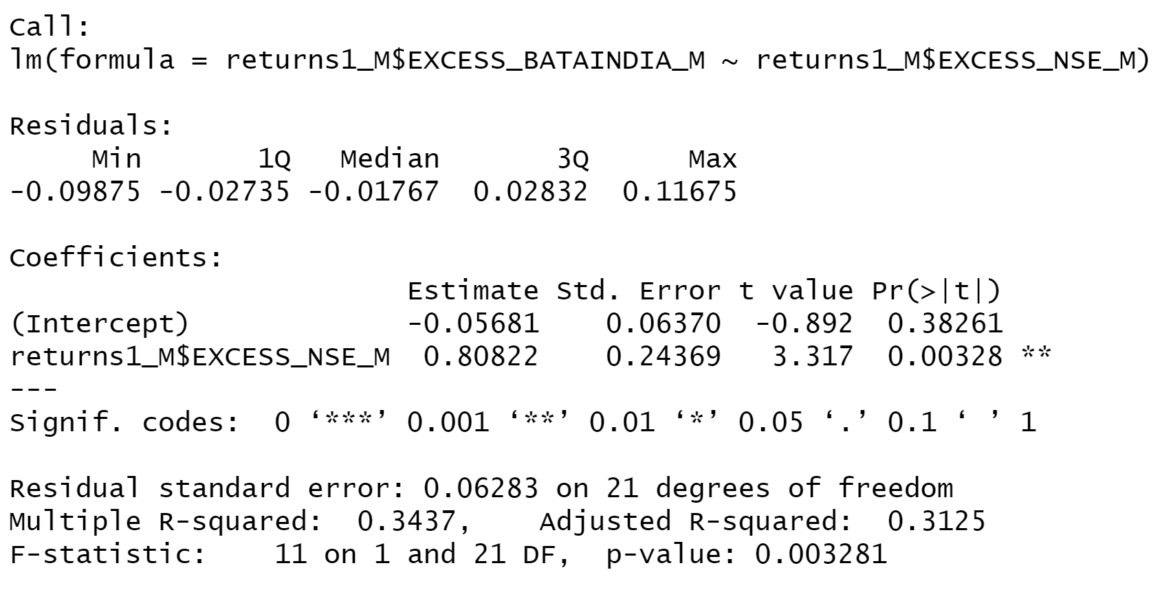

Figure 1.27: Results of Linear Regression for Monthly Returns of BATA

Based on the results from the CAPM we can see that the slope of regressed line is 0.80822 with an intercept of 0.05681. The p value for the slope being less than 0.05 indicating that the regression has a confidence interval of 95%.

**Economic Interpretation**: Beta of the regression was found out to be 0.81 which indicates that the security is less sensitive to changes in macroeconomic factors than the market. For a change of 1% in market return the security return will change by 0.81%.

### Estimating AR and MA coefficients using ARIMA Model

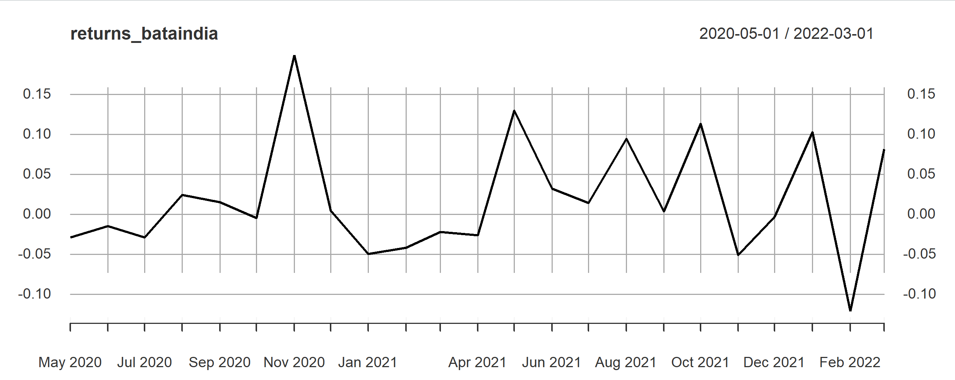

figure 1.28: Monthly Returns of BATA vs Date

The Augmented Dickey- Fuller Test was used for the stationary returns and these are the results.

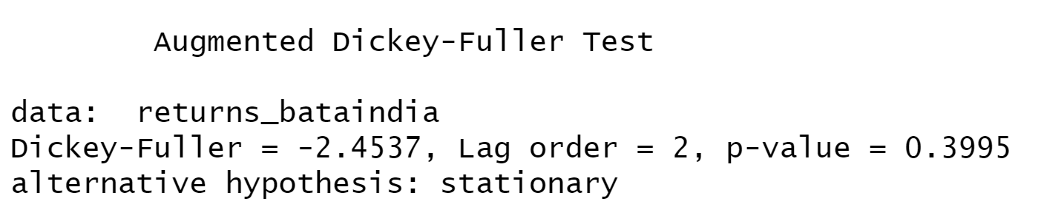

Figure 1.29: Augmented Dickey-Fuller Test for Monthly Returns of BATA

The p value is found to be 0.3995 which is greater than 0.05 meaning that the null hypothesis was not rejected and therefore the series were deemed not stationary.

**ACF Plot:**

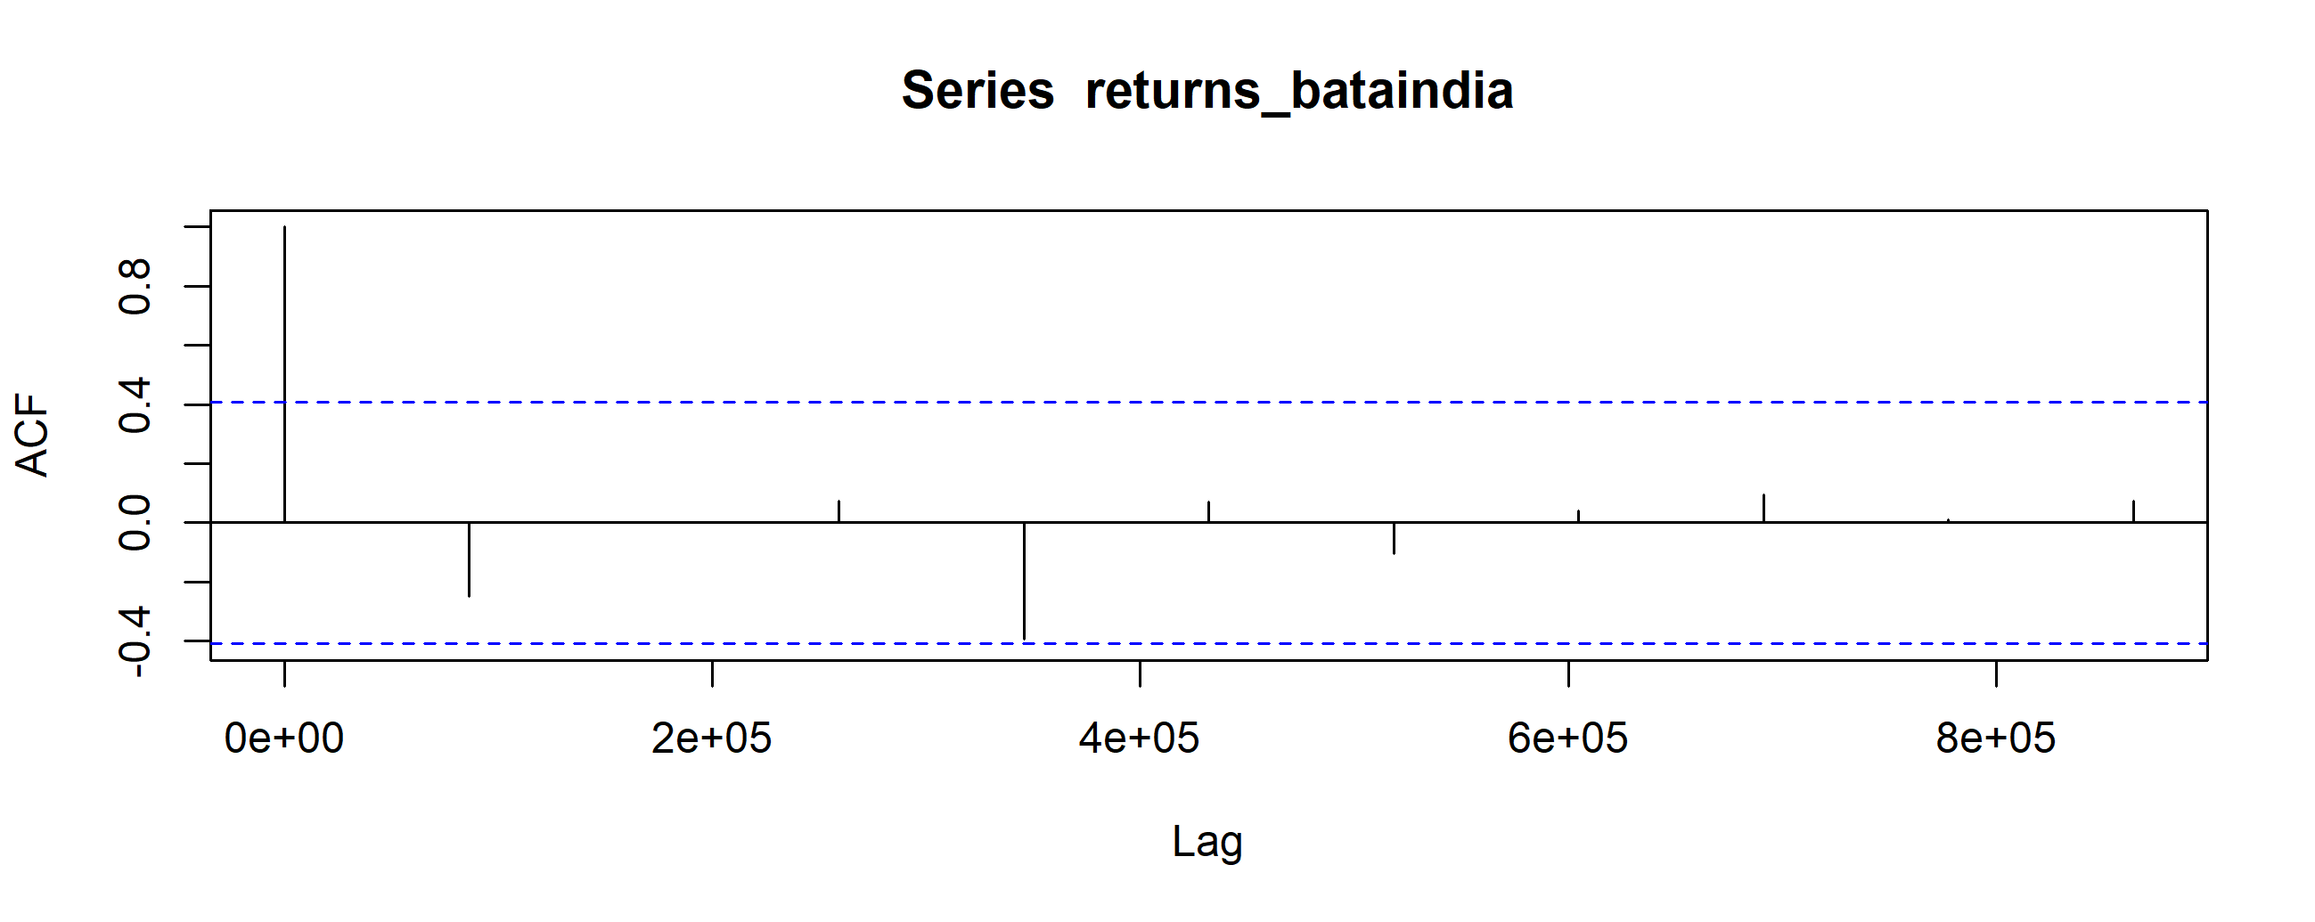

Figure 1.30: ACF Plot for Monthly Returns of BATA

The ACF property defines a distinct pattern for the autocorrelations. For a positive value of ϕ1, the ACF exponentially decreases to 0 as the lag h increases. For negative ϕ1, the 10 ACF also exponentially decays to 0 as the lag increases, but the algebraic signs for the autocorrelations alternate between positive and negative.

Since, the ACF is not significant for any value of lag, the order of the moving average model is zero. It is estimated to be a MA (0) model.

**PACF Plot:**

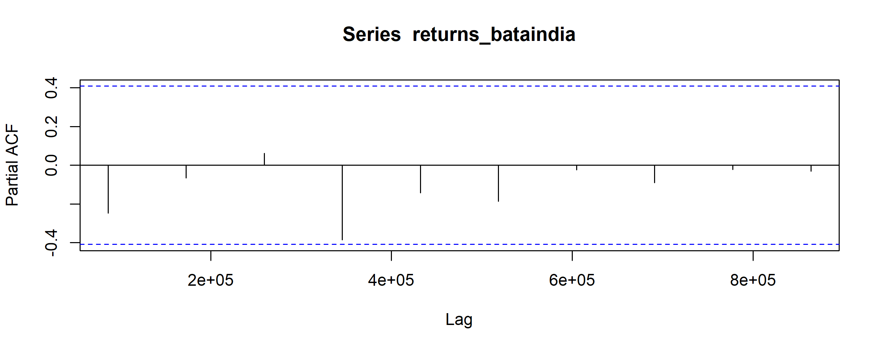

Figure 1.31: PACF Plot for Monthly Returns of BATA

Autocorrelation for all the lags are statistically unsignificant. This suggests a possible AR (0) model for these data. As can be seen from the graph above that the PACF is not significant for any value of lag, the order of the auto regressive model can be taken as zero.

After this, we run the ARIMA model on all orders (p,d,q) which we think might make a good model and choose the best amongst them. The best model is that which have the least AIC value. Using the ARIMA model, we predict the values for a small period of time and assess the model finally.

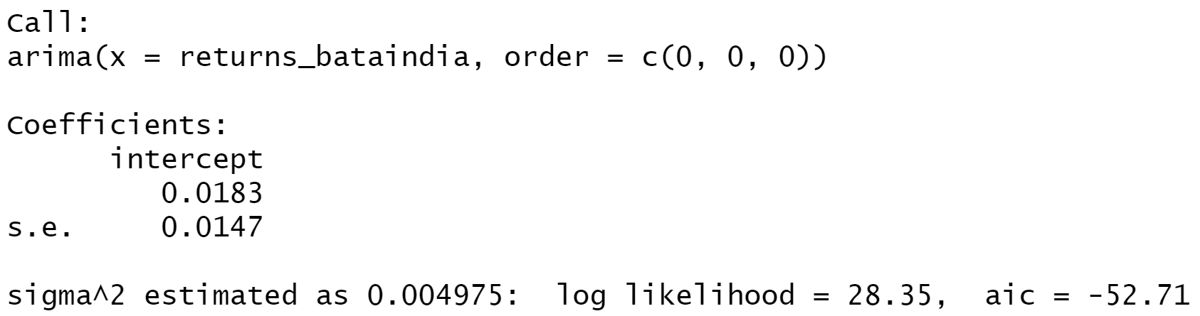

After running various (p,d,q) models we see that the least value of AIC is for the (0,0,0) which is what we estimated from ACF and PACF models.

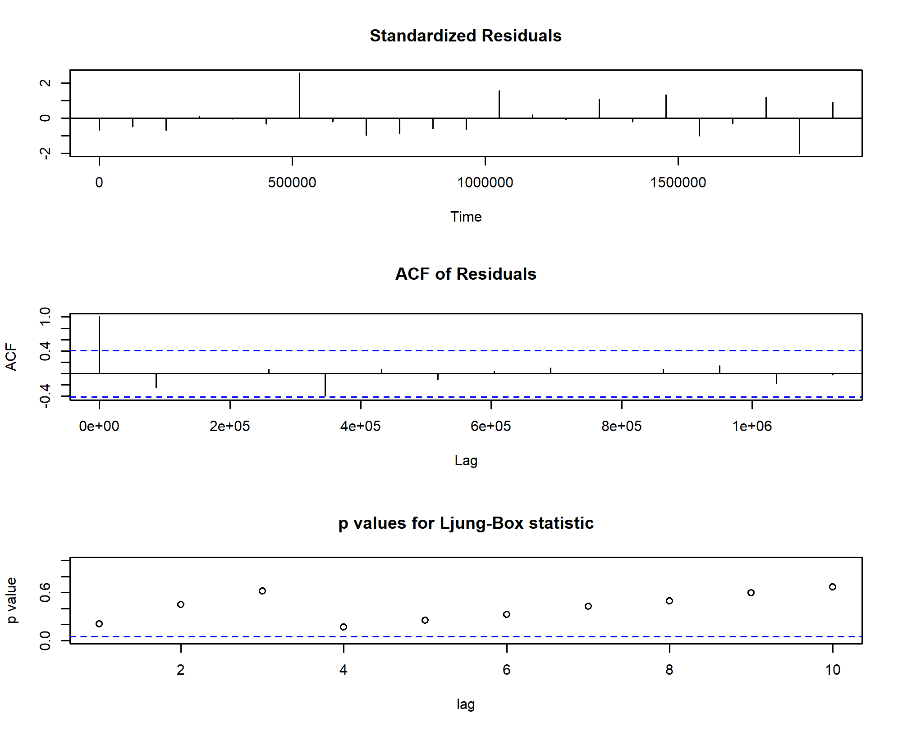

Figure 1.32: Diagnostic Model Test for Monthly Returns of BATA

**Prediction using the ARIMA model:**

The ARIMA Model was used to predict the return after the analysis period which end on 31 March, 2022. The forecast given by the model is given below.

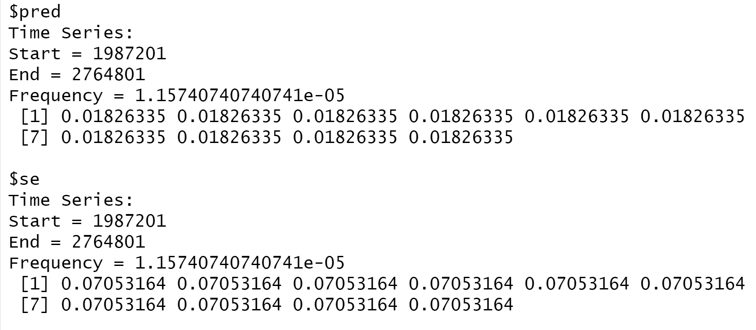

Figure 1.33: Forecasted Returns of BATA using ARIMA Model

### Forecasting volatility using GARCH and EGARCH Models

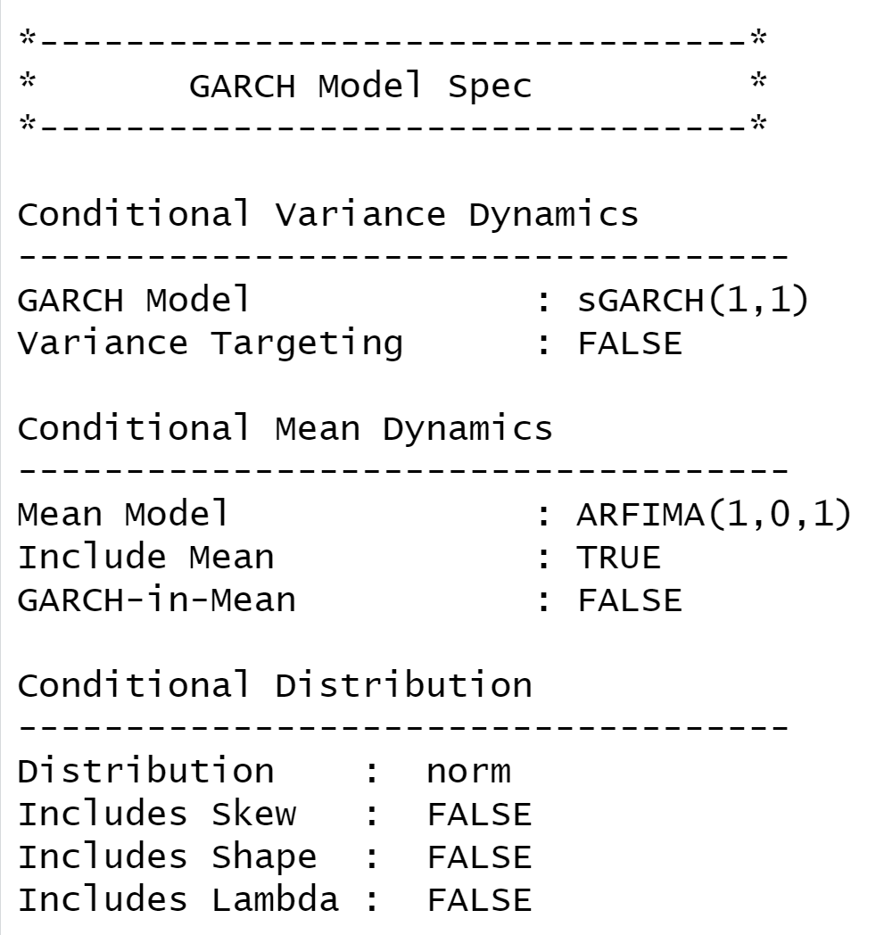

Figure 1.34: GARCH Specs for Monthly Returns of BATA

From above table we see that GARCH (1,1) is the most appropriate model and by default the mean model ARFIMA (1,0,1) is chosen.

We run the EGARCH model specs again on the monthly returns of BATA

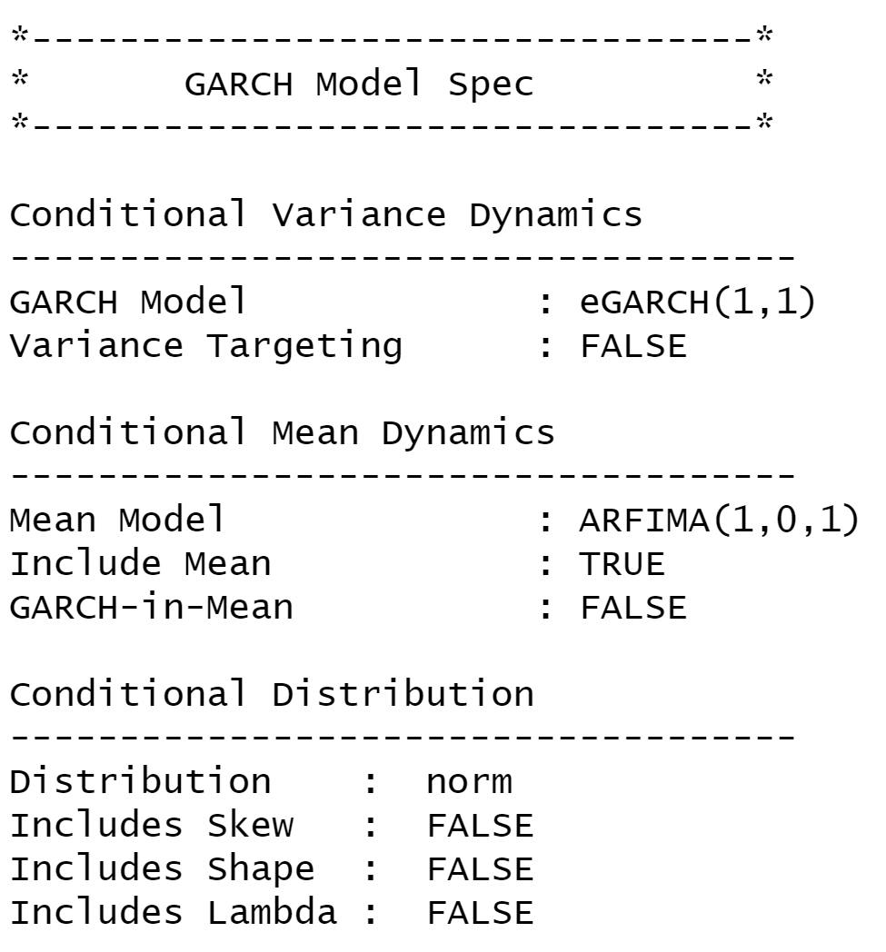

Figure 1.35: eGARCH Specs for Monthly Returns of BATA

From above table we can confirm that EGARCH (1,1) is the most appropriate model and by default the mean model ARFIMA (1,0,1) is chosen. These results are similar to what we observed for GARCH model.

**Estimating the Model:**

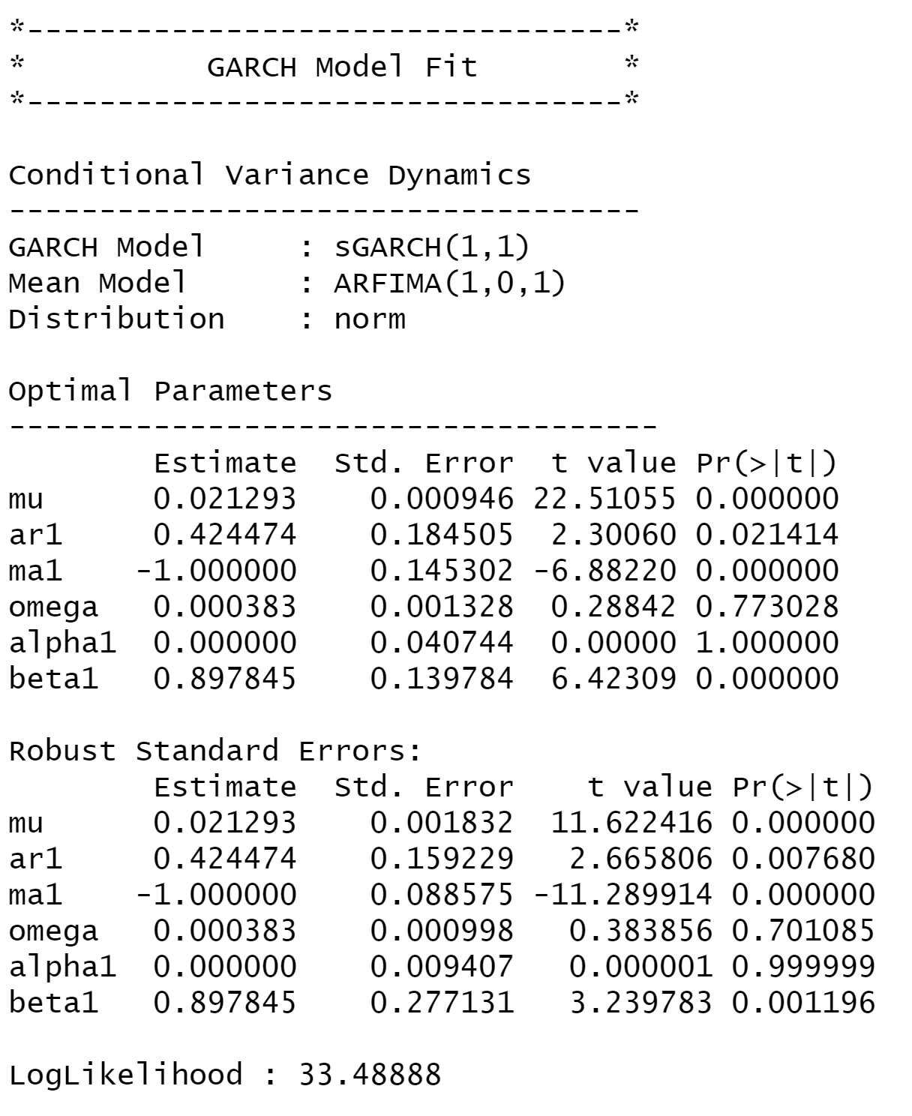

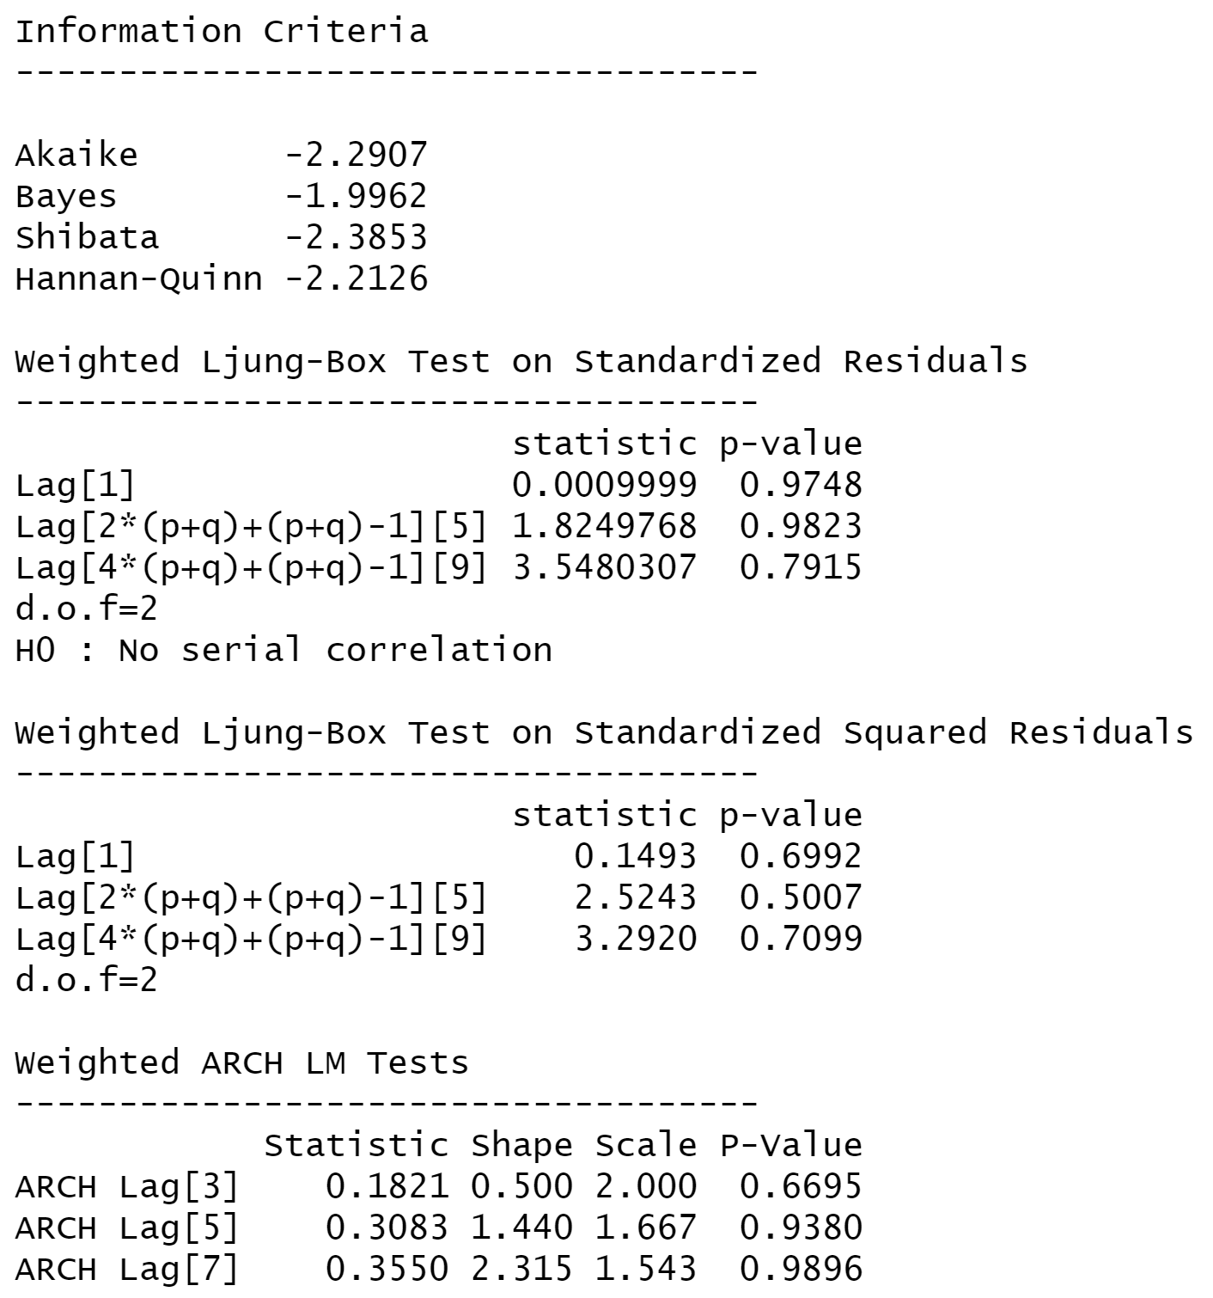

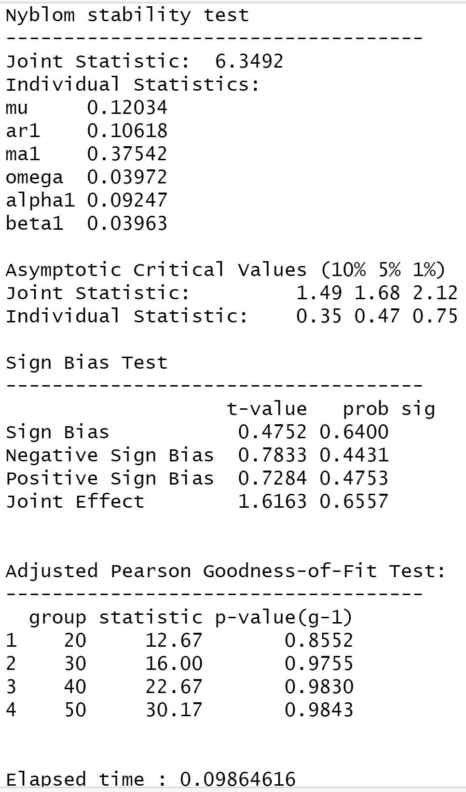

figure 1.36: Diagnostic Test of GARCH Model for Monthly Returns of BATA

**Interpretation:**

● In GARCH, the variance tends to show mean reversion which means it gets pulled to a long-term volatility rate over time.

● Here Omega, Alpha and Beta obtained from estimated standard error are given in the figure above.

**GARCH Model Forecast:**

Now we use the GARCH Model to forecast volatility after 31st March, 2021. The forecast are as follows:

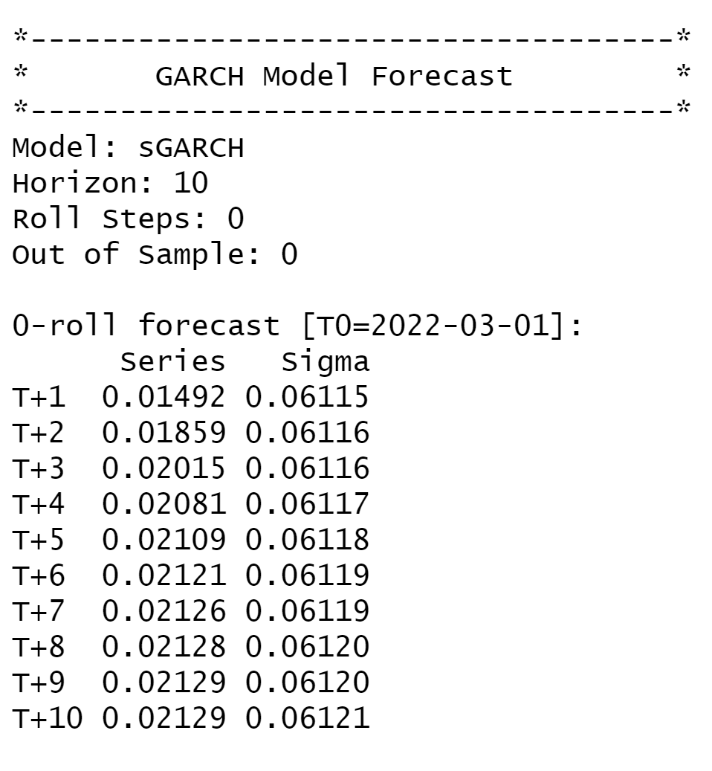

Figure 1.37: Forecasted Volatility of Monthly Returns of BATA

## Conclusion

* The beta from regression between the returns of BATAINDIA taken as dependent variable against NIFTY 50 as independent variable was completed and the beta was obtained for daily, weekly, and monthly as 0.79, 0.79 and 0.80822 respectively.
* ARIMA (0,0,0) model was found to be the best fit for forecasting returns in all three of the frequencies and the returns were forecasted for next 10 periods using the model itself.
* GARCH(1,1) model was also found to be the best fit to model the forecast regarding conditional volatility for all three frequencies and volatilities of the next 10 periods for BATAINDIA was forecasted using this model.

# BERGEPAINT

## About the company

### Nature of business

Berger Paints Ltd is an Indian multinational paint company, based in Kolkata, West Bengal. Berger Paints India Ltd is the second largest paint company in India. The company is engaged in manufacturing and selling of paints, varnishes and enamels for various applications. They are offering their customers a variety of innovative painting solutions. The company is headquartered in Kolkata and has a service network comprising of 110 stock points and 25000 dealers. Presently U.K Paints (India) Private Limited is the holding company of Berger Paints India.

### Ownership category

### How did it start?

The history of Berger Paints India Limited as a company started in 1923 as Hadfield's (India) Limited which was a small colonial venture producing ready-mixed stiff paints, varnishes, and distempers setup on 2 acres of land in one of India's first industrial towns close to Kolkata in Howrah, Bengal. Subsequently in 1947, British Paints (Holdings) Limited, an international consortium of paint manufacturing companies bought over Hadfield's (India) Limited and thus the name changed to British Paints (India) Ltd. The gentleman who took over, as its first managing director was Mr. Alexender Vernon Niblet, an Englishman who was later on followed by Mr. Alfred Godwin in 1962.

Further in the year 1965, the share capital of British Paints (Holdings) Limited was acquired by Celanese Corporation, USA and the controlling interest of British Paints (India) Ltd was acquired by CELEURO NV, Holland, a Celanese subsidiary.

Subsequently in 1969, the Celanese Corporation sold its Indian interests to Berger, Jenson & Nicholson, U.K. Then onwards the company British Paints (India) Ltd became a member of the worldwide BERGER group having its operations across oceans in numerous geographies and this marked the beginning of Lewis Berger's legacy in India – which the company would later take forward to enviable heights. From 1973 the company entered into one of its dynamic phases of business with introduction of new generation products in the industrial, marine and decorative segments under the able leadership of its first Indian Managing Director Mr. Dongargaokar Madhukar.

Year 1976 was another turning point in the history of the company when the foreign holding in the company was diluted to below 40% by sale of a portion of the shares to the UB Group controlled by Mr. Vittal Mallya. The reins of the company were taken over by Mr. Biji K Kurien as its Chief Executive & Managing Director in the year 1980. Finally in the year 1983, the British Paints (India) Limited, changed its name to Berger Paints India Limited.

### Significance in the industry

Berger Paints has been serving the customers for decades now. Their policy is built around customer satisfaction and delivering upon the expectations of the customers. They do everything in their power to make sure their customers keep coming back again and again and with this policy they have maintained their position as the second-best paint company across India.

### Overall greatness of the company

Berger Paints India has won multiple awards for its performance and customer satisfaction over the years. It has even featured in Forbes India’s Super 50 Companies back in 2016 and has consistently been ranked as the top 10 in coatings company.

## Daily Returns Analysis

### Estimating Beta using CAPM Model

The Capital Asset Pricing Model is written is written as

**E(Ri) = Rf + βi *(Rm-Rf )**

Where:

E(Ri)= Expected rate of return of asset

Rf = Risk free rate

βi = Sensitivity to excess returns

Rm = Market returns (NIFTY 50)

Beta (levered) is obtained from performing a linear regression of a security’s excess return (dependent variable) against the excess returns of the market over the risk-free rate. The slope obtained from the regression is the Beta which tells us how sensitive the security’s return is to any change in market returns.

For daily analysis, returns of the security was calculated from 1st Apr 2020 to 31st Mar 2022. For calculating the returns, the closing prices of the stock was used and excess return over the risk-free rate was calculated for both the security and NIFTY 50.

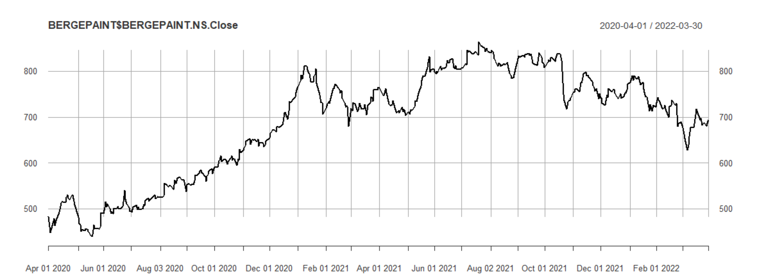

figure 2.1: Daily Closing Price of BERGEPAINT vs Date

Returns of the security was again observed for further analysis, however, no specific pattern was observed from the plot as the returns usually kept oscillating in the range of -5% to 5% with some days having return more than 5% while some days having returns less than -5%.

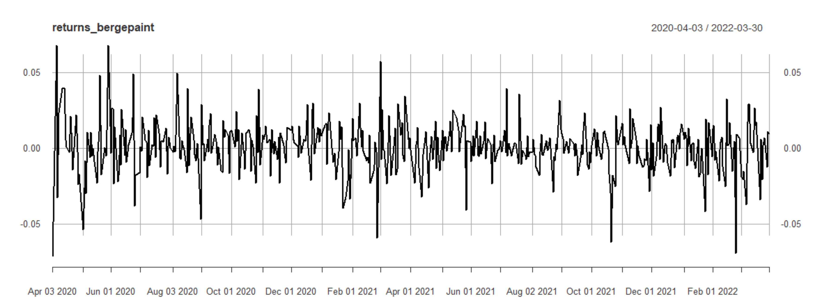

figure 2.2: Daily Returns of BERGEPAINT vs Date

Linear regression was performed for excess returns of BERGEPAINT’s daily return over the risk-free rate against the excess NIFTY50 return and the following result was obtained.

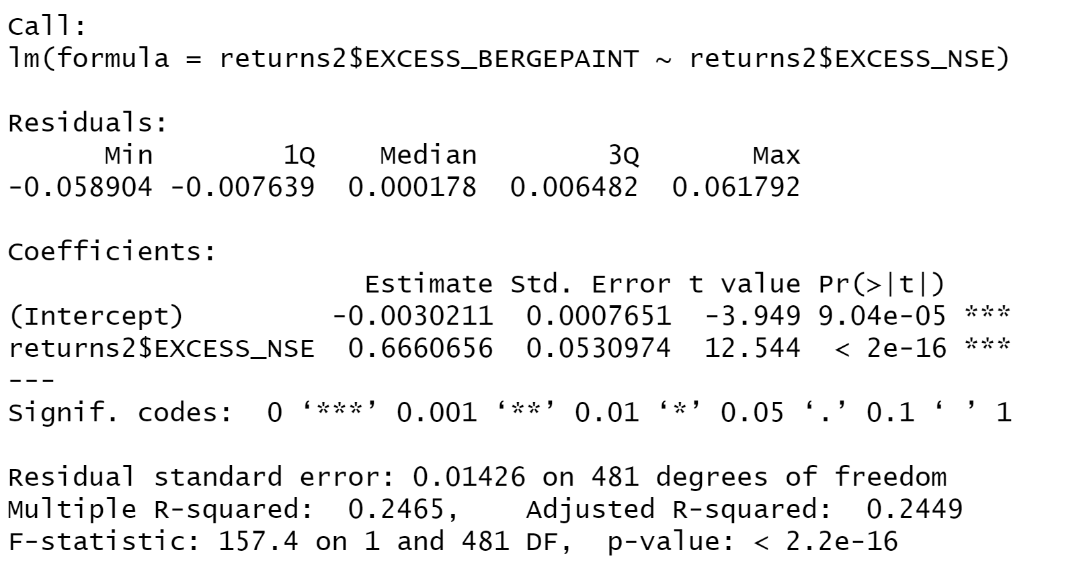

Figure 2.3: Results of Linear Regression for Daily Returns of BERGEPAINT

Slope of the regression line gives us the value of βi for any security which in this case would be the sensitivity of BERGEPAINT to market returns. Here the value of βi obtained was 0.666 and the intercept obtained is -0.003. The p-value of the slope is found to be less than 0.05 which means that the slope is significant on a 95% confidence interval.

Economic Interpretation: βi of the regression was found to be 0.666 so we can interpret that for every 1% change in market return the return of BERGEPAINT would change by 0.666% in the same direction. With a value of Beta, we can interpret how sensitive the security is to macroeconomics factor of the market.

### Estimating AR and MA coefficients using ARIMA Model

ARIMA stands for autoregressive integrated moving average. ARIMA model is often used to analyze events over a period and use the past data to predict the future data. For ARIMA models, the standard notation followed is (p, d, q) where integer values are substituted in values of p, d and q to indicate what type of ARIMA model is being used. The parameters can be defined as:

* **p:** Represents the lag order or the number of lag observations in the model.
* **d:** Represents the degree of differencing or the number of times the raw observation is differenced.
* **q:** Represents the order of moving average.

The AR which is obtained from PACF correlogram gives the value of p, count of the differentiation gives the value of d and the order of the MA obtained from ACF correlogram gives the value of q. The AR and MA coefficients of BERGEPAINT are estimated by running the ACF and PACF plots.



figure 2.4: Daily Returns of BERGEPAINT vs Date

In order to confirm the stationarity of the return series, Augmented Dickey-Fuller test is conducted on the returns. Results obtained were as follows:

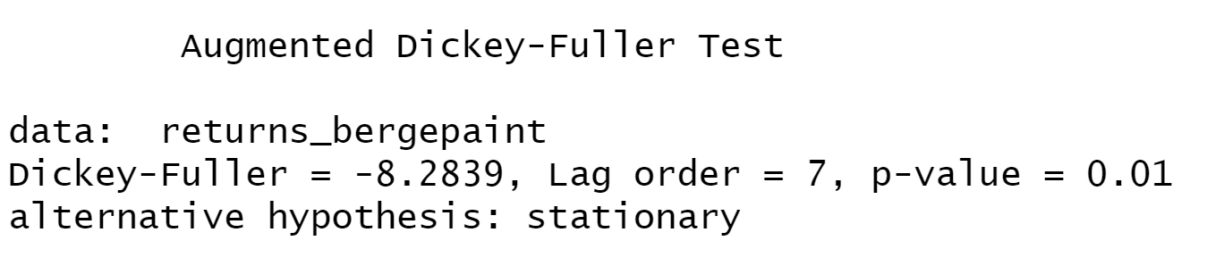

Figure 2.5: Augmented Dickey-Fuller Test for Daily Returns of BATA

The p-value obtained is 0.01 which is less than 0.05 which implies that the series is stationary as we reject the null hypothesis. The series is found to be stationary. Hence it should satisfy properties like the mean of E(yt) and the variance of yt is the same for all t. Also, the covariance and correlation between yt and yt-1 is the same for all t.

**ACF Plot**

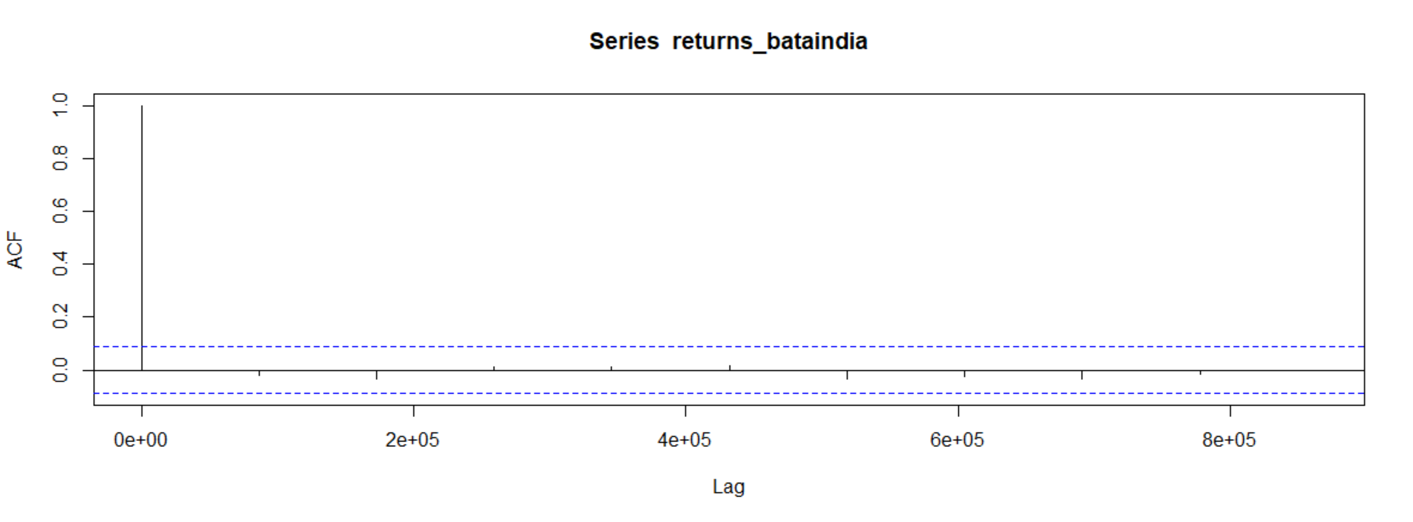

Figure 2.6: ACF Plot for Daily Returns of BERGEPAINT

The ACF property gives a distinct pattern for the autocorrelations. For a positive value of ϕ1, as the lag h increases, the ACF will exponentially decrease to 0 whereas for negative ϕ1 the ACF exponentially decays to 0 as the lag increases.

As the ACF is not significant for any value of lag, the order of the MA would be zero. Hence, it is estimated to be a MA(0) model.

**PACF Plot**

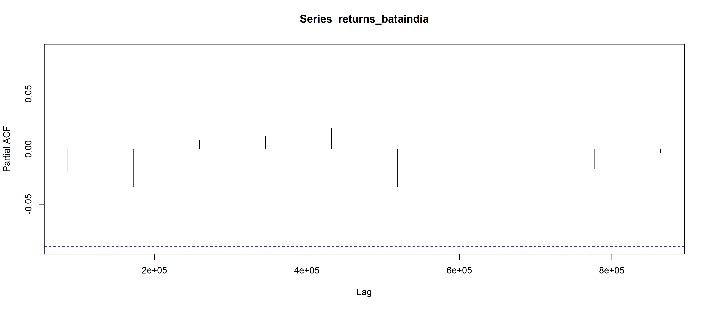

Figure 2.7: PACF Plot for Daily Returns of BATA

For all the lags, the autocorrelation is statistically insignificant. With this it can possibly be an AR(0) model as per these data. As observed from the above plot that PACF is not significant for any value of lag, the order of the autoregressive model is taken as 0.

Following this, ARIMA model is made to run on all orders of (p, d, q) and the best model parameters are chosen amongst them. The model with the least AIC value is considered to be the best model. ARIMA model is used for predicting the values for a small period of time.

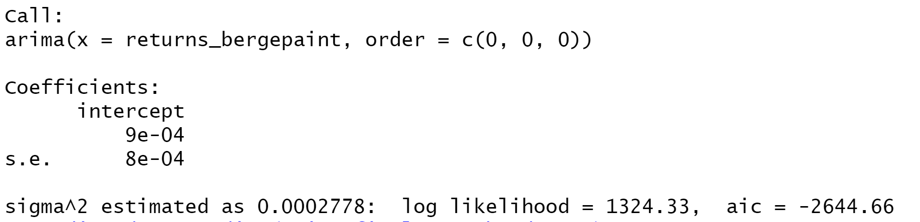

Figure 2.8: ARIMA Model Test for Daily Returns

After running various (p, d, q) models we see that the least value of AIC obtained is for (0,0,0) which is in line with our estimate from analyzing the ACF and PACF plot.

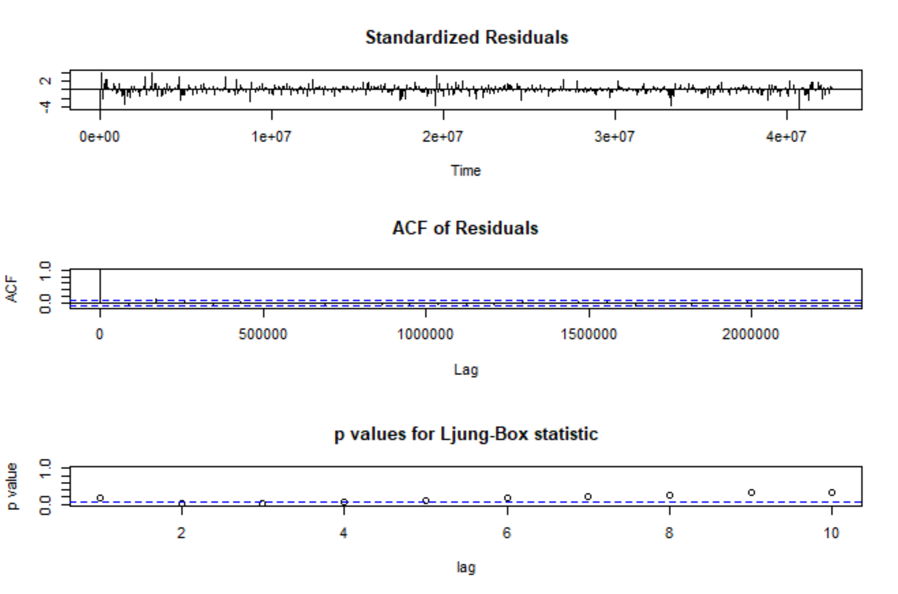

**Interpretation:**

* Standardized Residuals of the models are found to be randomly distributed.
* The ACF of the residuals is not found to be significant for any value lag.
* The p-values of the Ljung-Box is on an average found to be greater than 0.05 which is indicated by the blue line.

Therefore, on the basis of these observations we can conclude that the model is a good fit.

**Prediction using the ARIMA Model:**

The ARIMA Model is then used to predict the returns after the analysis period which ends on 31st of March 2022. The forecast obtained from the model is as follows:

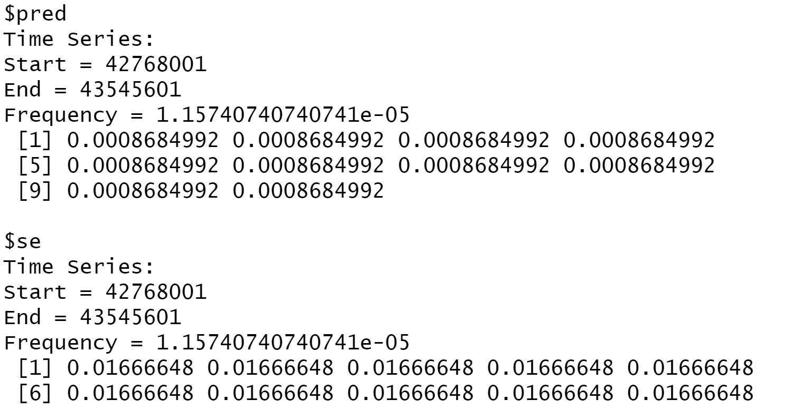

Figure 2.9: Forecasted Returns of BERGEPAINT using ARIMA Model

### Forecasting volatility using GARCH and EGARCH Models

GARCH stands for Generalized Autoregressive Conditional Heteroskedasticity. It is commonly used while modelling financial time series. It works on the concept of volatility clustering which suggests that higher volatility is followed by higher volatility and the same for lower. A GARCH model working requires three specifications to be made,

* A Mean Equation,
* A Variance Equation,
* A Distributional assumption.

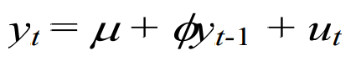

Mean Equation

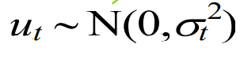

Distributional Assumption

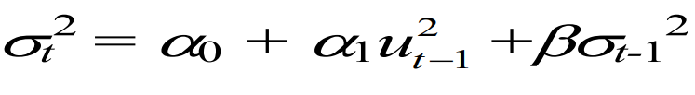

Variance Equation

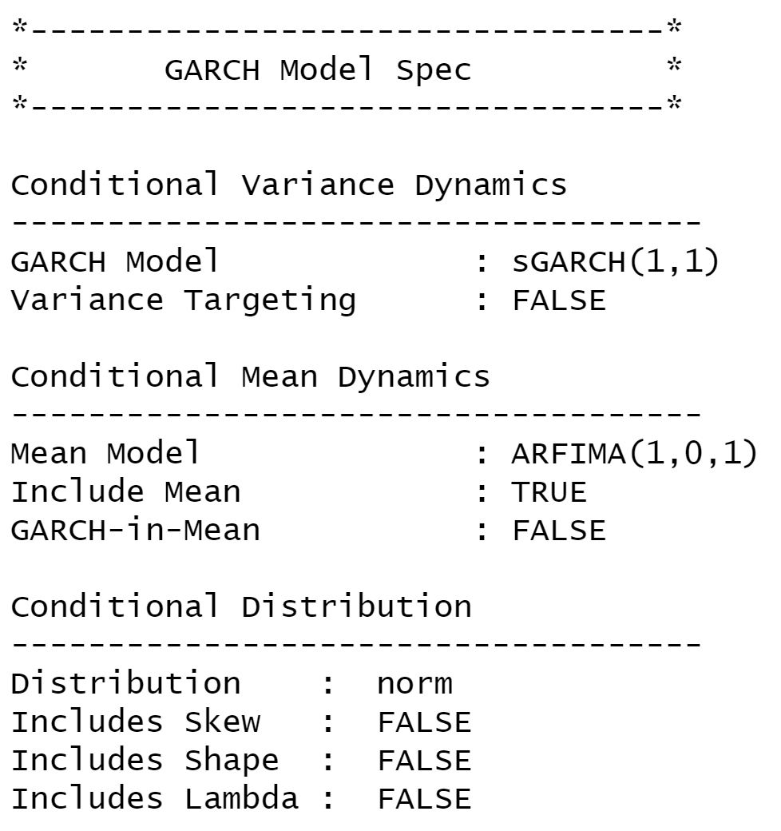

Figure 2.10: GARCH Specs for Daily Returns of BERGEPAINT

From above table we see that GARCH (1,1) is the most appropriate model and by default the mean model ARFIMA (1,0,1) is chosen.

We run the EGARCH models again on the daily returns of BERGEPAINT.

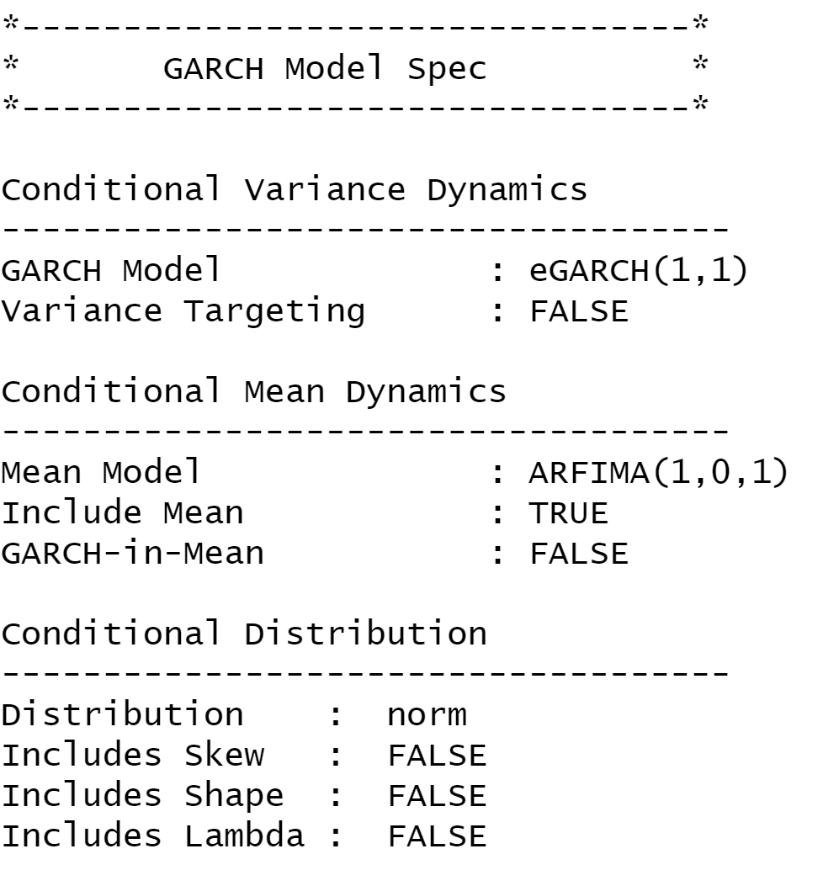

Figure 2.11: GARCH Specs for Daily Returns of BERGEPAINT

From above table we see that EGARCH (1,1) is the most appropriate model and by default the mean model ARFIMA (1,0,1) is chosen. These results are similar to what we observed for GARCH model.

**Estimating the model:**

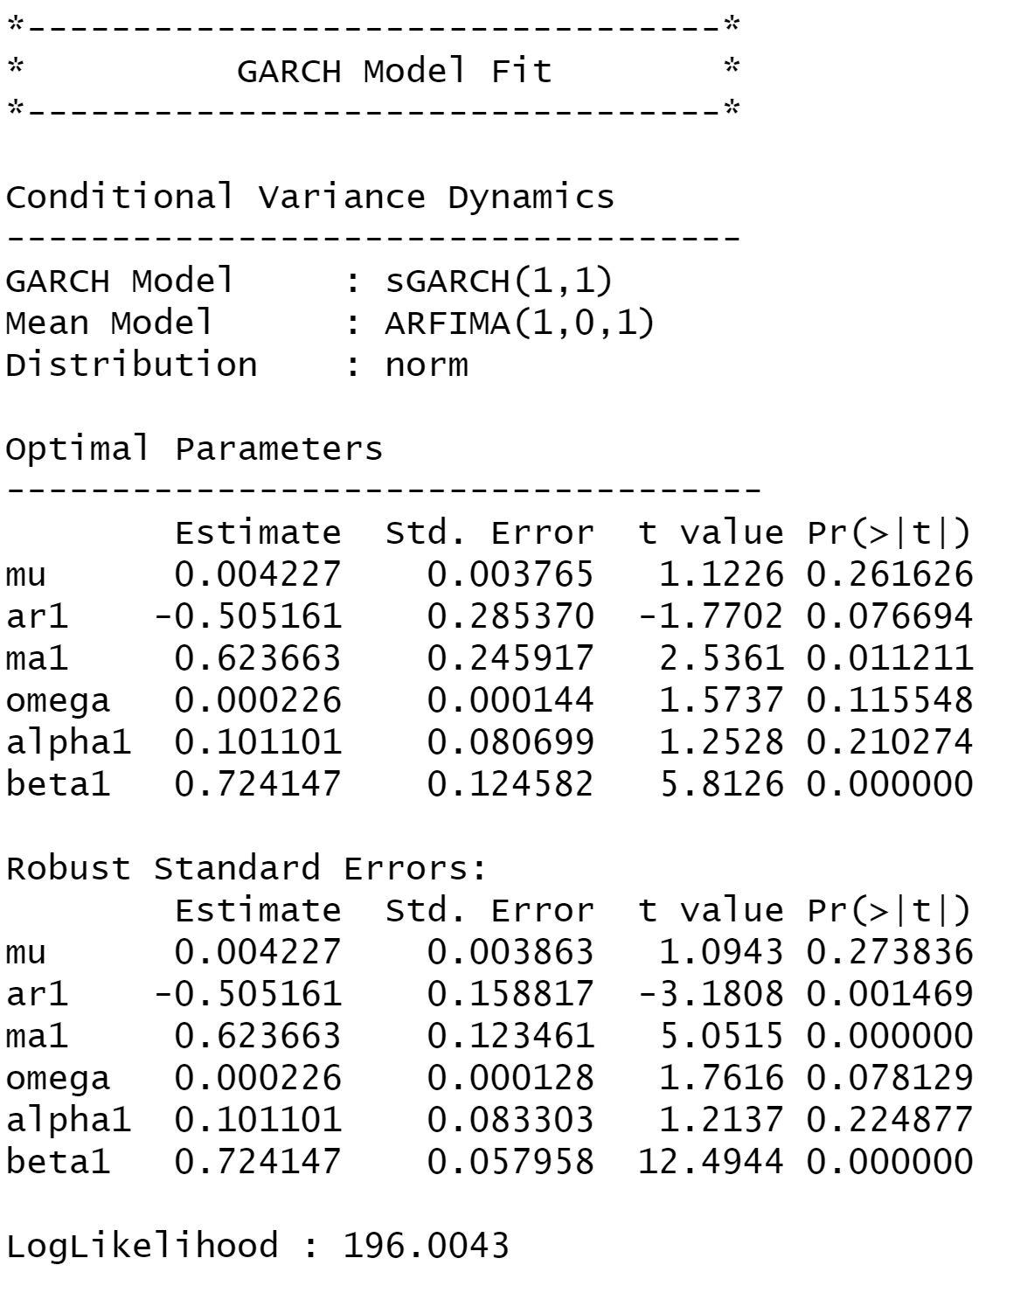

figure 2.12: Diagnostic Test of GARCH Model for Daily Returns of BERGEPAINT

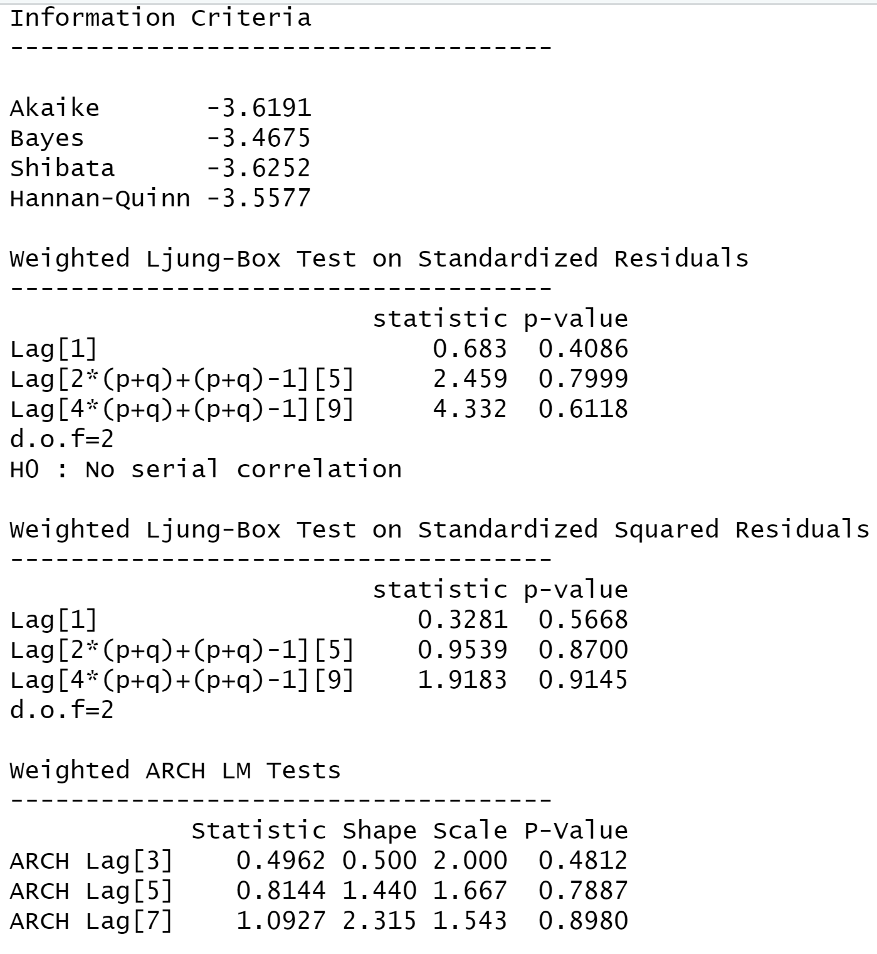

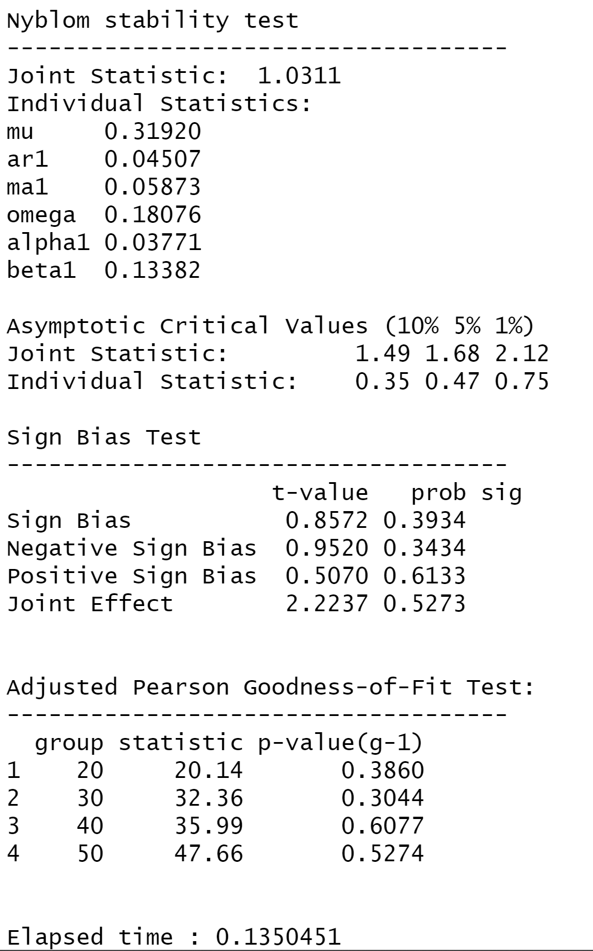

**Interpretation:**

* In GARCH, the variance tends to show mean reversion which means it gets pulled to a long-term volatility rate over time.
* Here Omega, Alpha and Beta are obtained from estimated standard error are given in the figure above.

**GARCH Model Forecast:**

Now we use the GARCH Model to forecast volatility after 31st March, 2022. The forecast obtained was as follows.

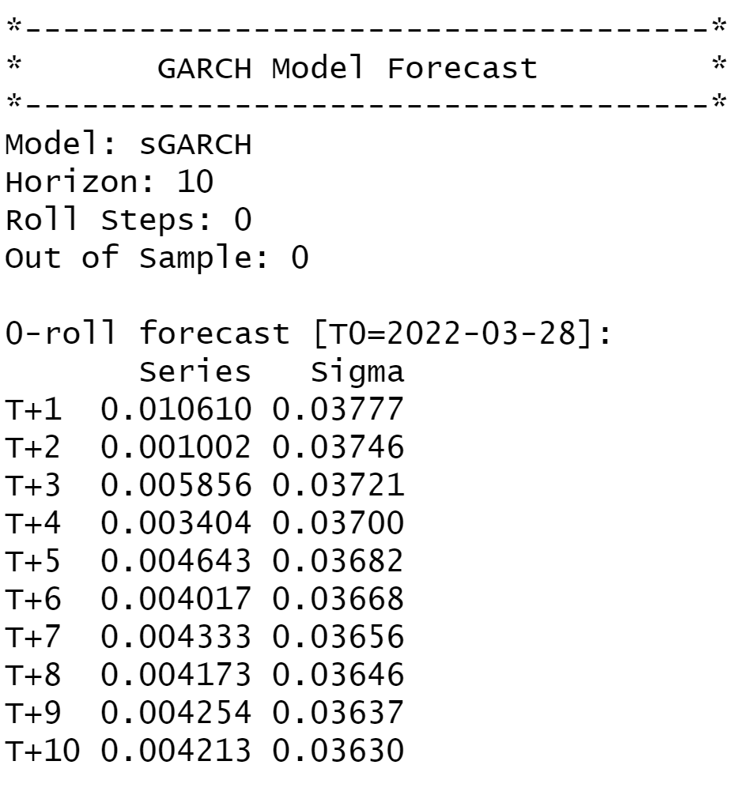

Figure 2.13: Forecasted Volatility of Daily Returns of BERGEPAINT

## Weekly Returns Analysis

### Estimating Beta using CAPM Model

The Capital Asset Pricing Model is written is written as

**E(Ri) = Rf + βi *( Rm-Rf )**

Where:

E(Ri)= Expected rate of return of asset

Rf = Risk free rate

βi = Sensitivity to excess returns

Rm = Market returns (NIFTY 50)

Beta (levered) is obtained from performing a linear regression of a security’s excess return (dependent variable) against the excess returns of the market over the risk-free rate. The slope obtained from the regression is the Beta which tells us how sensitive the security’s return is to any change in market returns.

For weekly analysis, returns of the security was calculated from 1st Apr 2020 to 31st Mar 2022. For calculating the returns, the weekly closing prices of the stock was used and excess return over the risk-free rate was calculated for both the security and NIFTY 50.

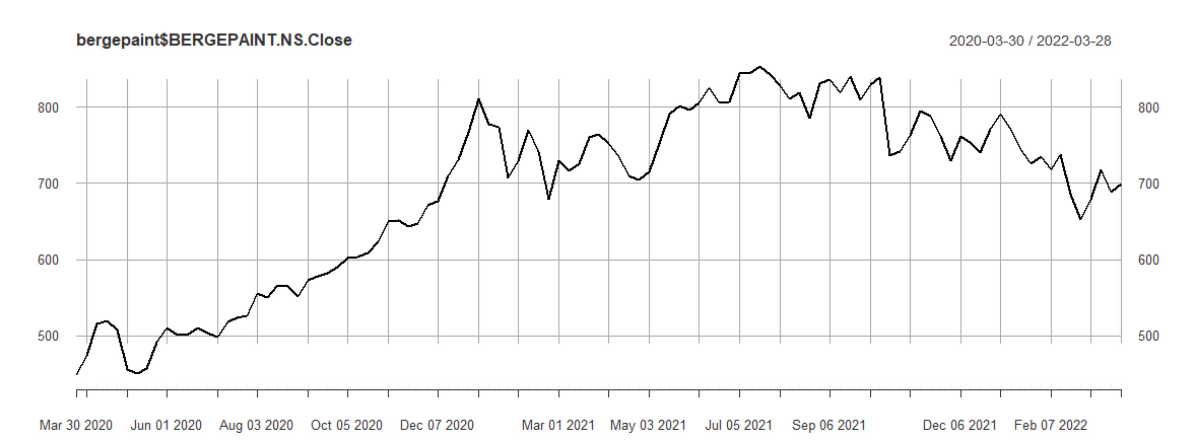

figure 2.14: Weekly Closing Price of BERGEPAINT vs Date

Returns of the security was again observed for further analysis, however, no specific pattern was observed from the plot as the returns usually kept oscillating in the range of -5% to 5% with some days having return as high as 10% while some days having returns less than -10%.

The excess weekly returns are regressed as the dependent variable with the excess market returns as the independent variable.

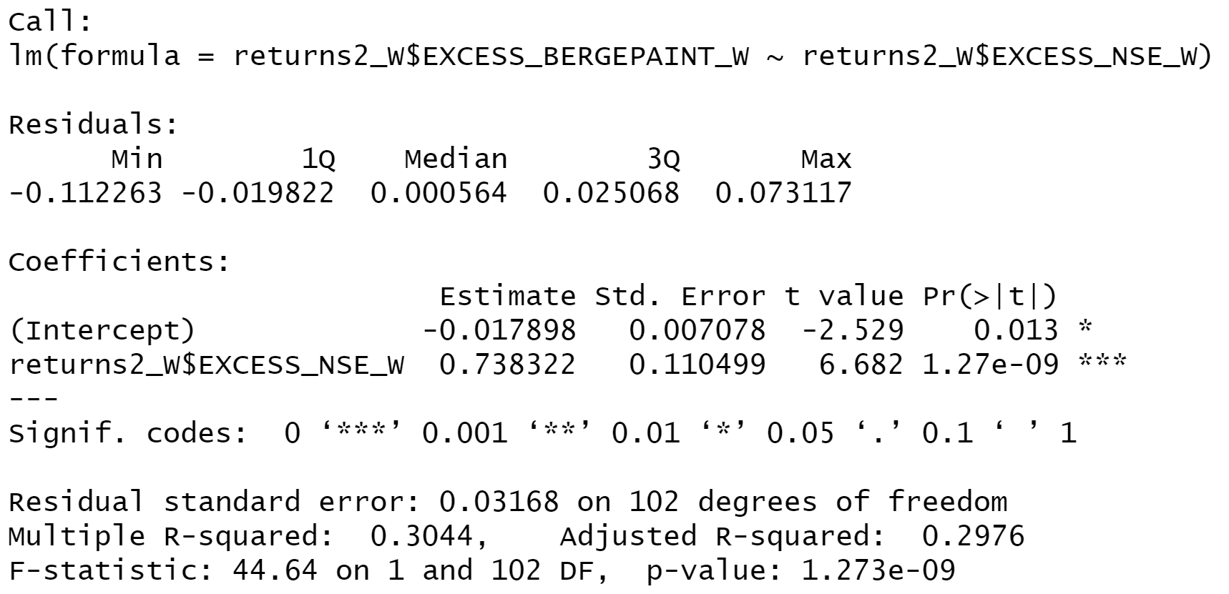

figure 2.15: Weekly Returns of BERGEPAINT vs Date

Based on the results from the CAPM we can see that the slope of regressed line is 0.738322 with an intercept of -0.017898. The p value for the slope being less than 0.05 indicating that the regression has a confidence interval of 95%.

**Economic Interpretation**: Beta of the regression was found out to be 0.74 which indicates that the security is less sensitive to changes in macroeconomic factors than the market. For a change of 1% in market return the security return will change by 0.74%.

### Estimating AR and MA coefficients using ARIMA Model

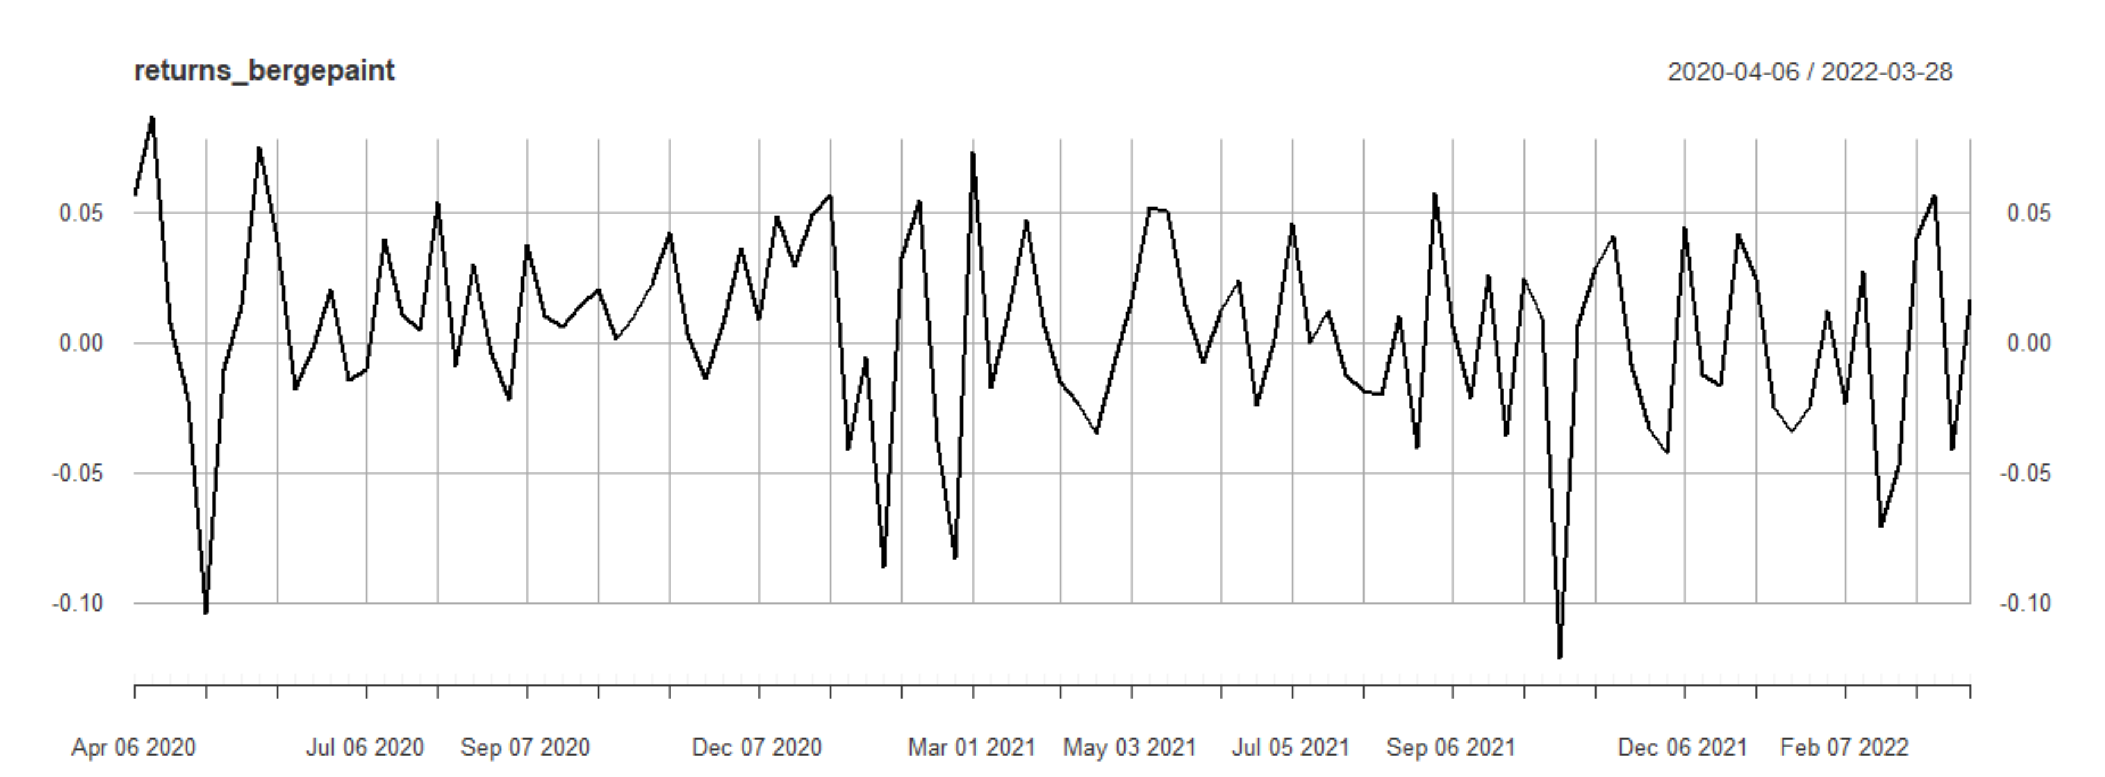

figure 2.16: Weekly Returns of BERGEPAINT vs Date

In order to confirm the stationarity of the return series, Augmented Dickey-Fuller test is conducted on the returns. Results obtained were as follows:

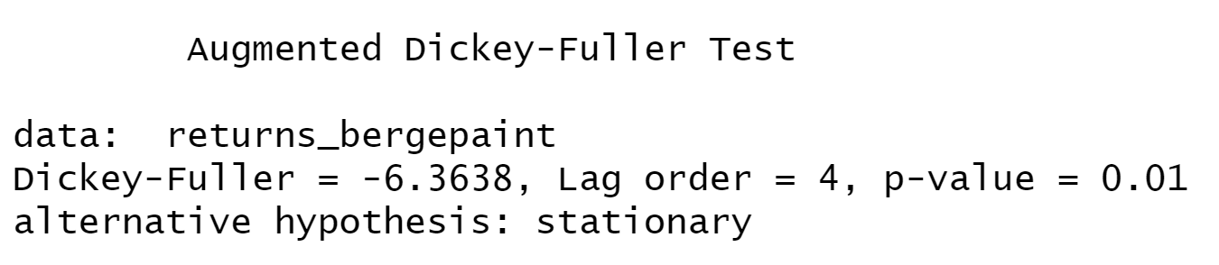

Figure 2.17: Augmented Dickey-Fuller Test for Weekly Returns of BERGEPAINT

The p-value obtained is 0.01 which is less than 0.05 which implies that the series is stationary as we reject the null hypothesis. The series is found to be stationary. Hence it should satisfy properties like the mean of E(yt) and the variance of yt is the same for all t. Also, the covariance and correlation between yt and yt-1 is the same for all t.

**ACF Plot**

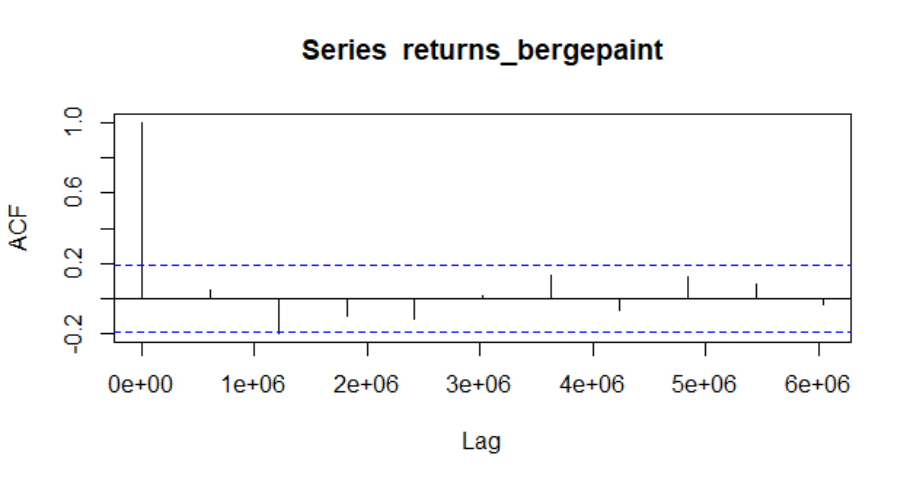

Figure 2.18: ACF Plot for Weekly Returns of BERGEPAINT

The ACF property gives a distinct pattern for the autocorrelations. For a positive value of ϕ1, as the lag h increases, the ACF will exponentially decrease to 0 whereas for negative ϕ1 the ACF exponentially decays to 0 as the lag increases.

As the ACF is significant for 3 values of lag, the order of the MA would be 3. Hence, it is estimated to be a MA (3) model.

**PACF Plot**

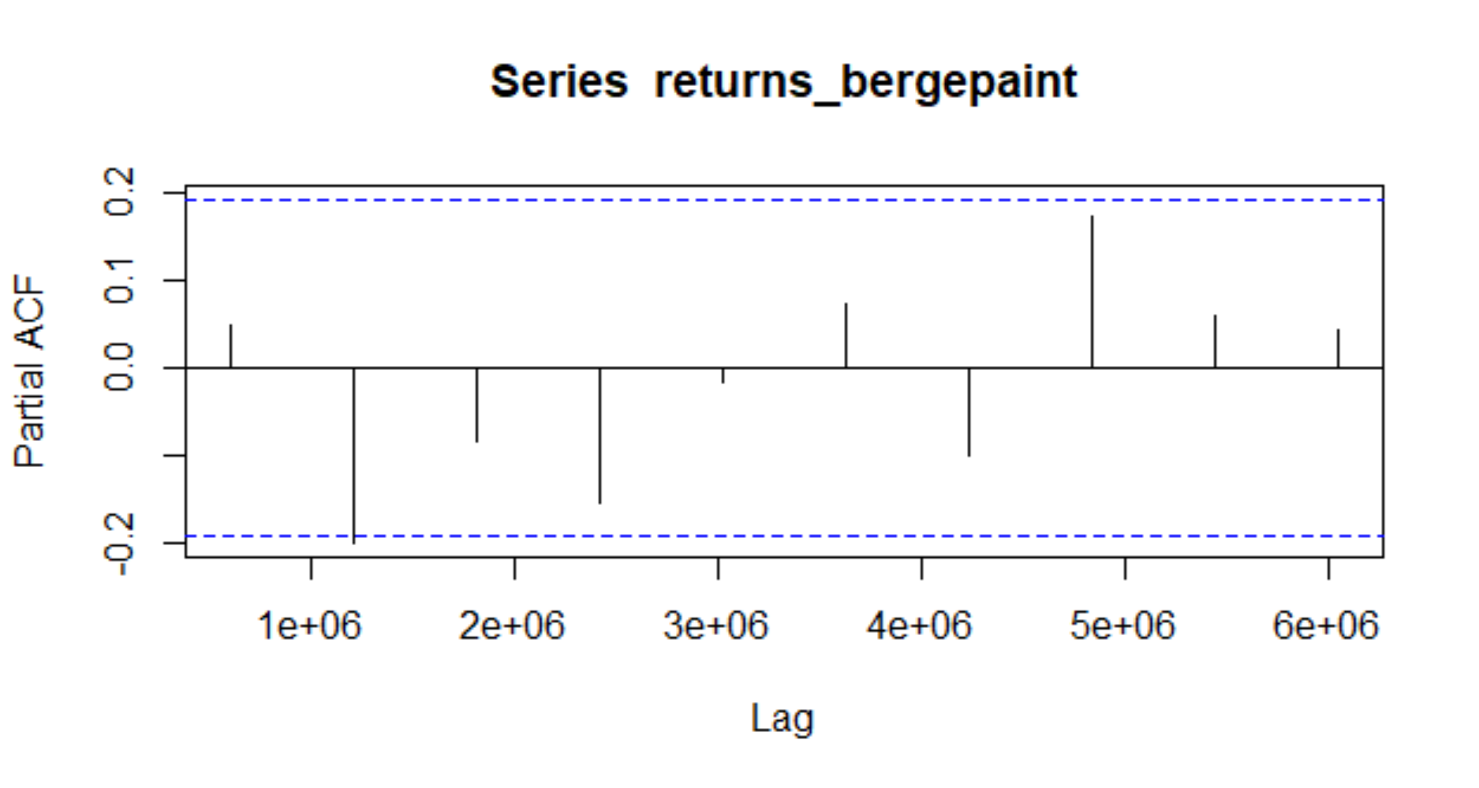

Figure 2.19: PACF Plot for Weekly Returns of BERGEPAINT

Autocorrelation for all the lags is statistically insignificant. This suggests a possible AR (0) model for these data. As can be seen from the graph above that the PACF is not significant for any value of lag, the order of the auto regressive model can be taken as zero

After this, we run the ARIMA model on all orders (p,d,q) which we think might make a good model and choose the best amongst them. The best model is that which have the least AIC value. Using the ARIMA model, we predict the values for a small period of time and assess the model finally.

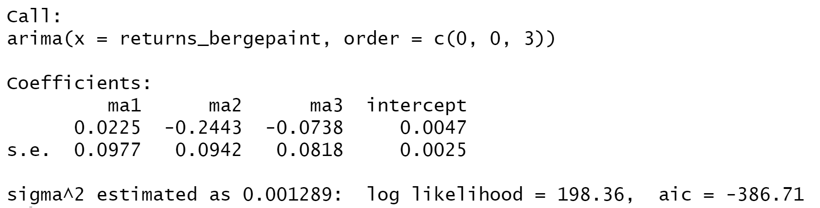

After running various (p,d,q) models we see that the least value of AIC is for the (0,0,3) which is what we estimated from ACF and PACF models.

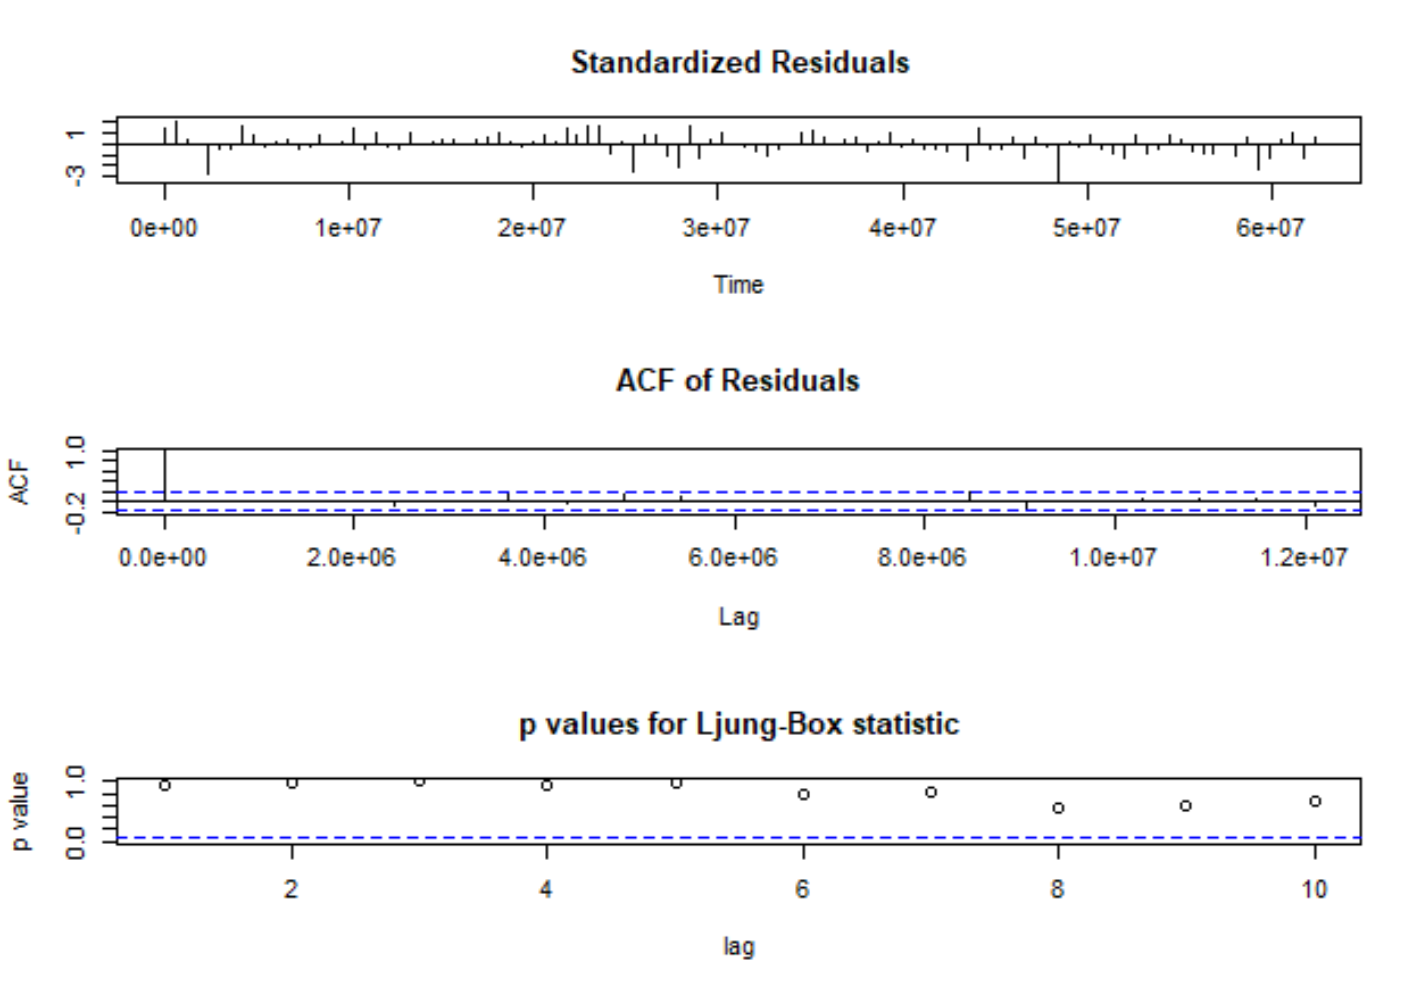

Figure 2.20: ARIMA Model Test for Weekly Returns

**Prediction using the ARIMA model:**

The ARIMA Model was used to predict the return after the analysis period which end on 31 March, 2022. The forecast given by the model is given below.

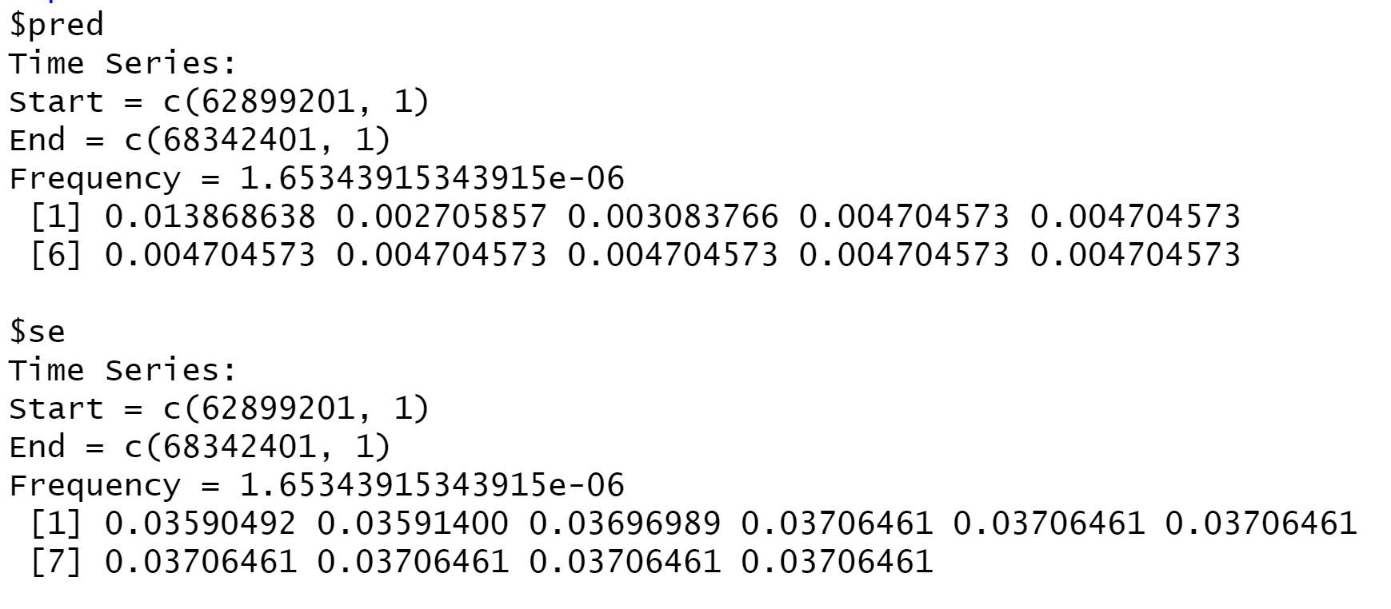

Figure 2.21: Forecasted Returns of BERGEPAINT using ARIMA Model

### Forecasting volatility using GARCH and EGARCH Models

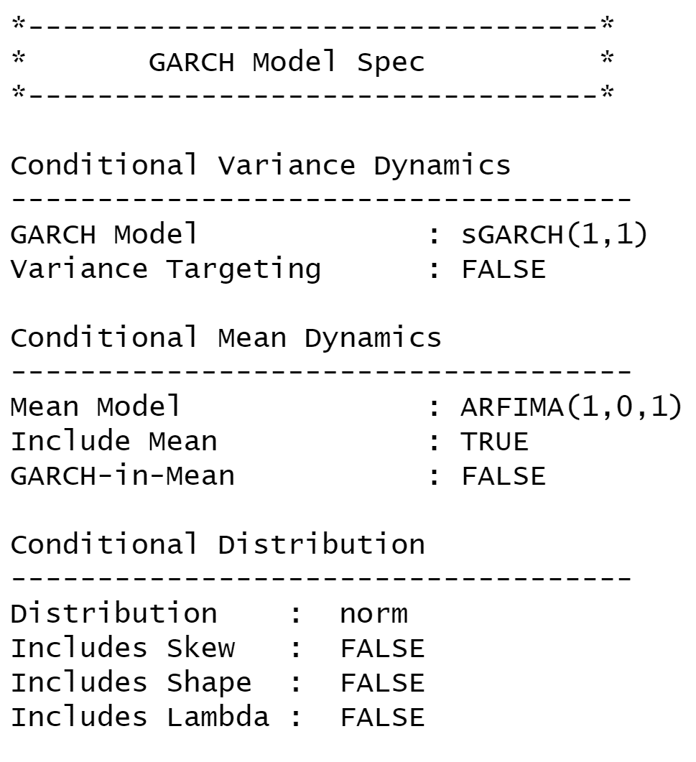

Figure 2.22: GARCH Specs for Weekly Returns of BERGEPAINT

From above table we see that GARCH (1,1) is the most appropriate model and by default the mean model ARFIMA (1,0,1) is chosen.

We run the EGARCH models again on the weekly returns of BERGEPAINT.

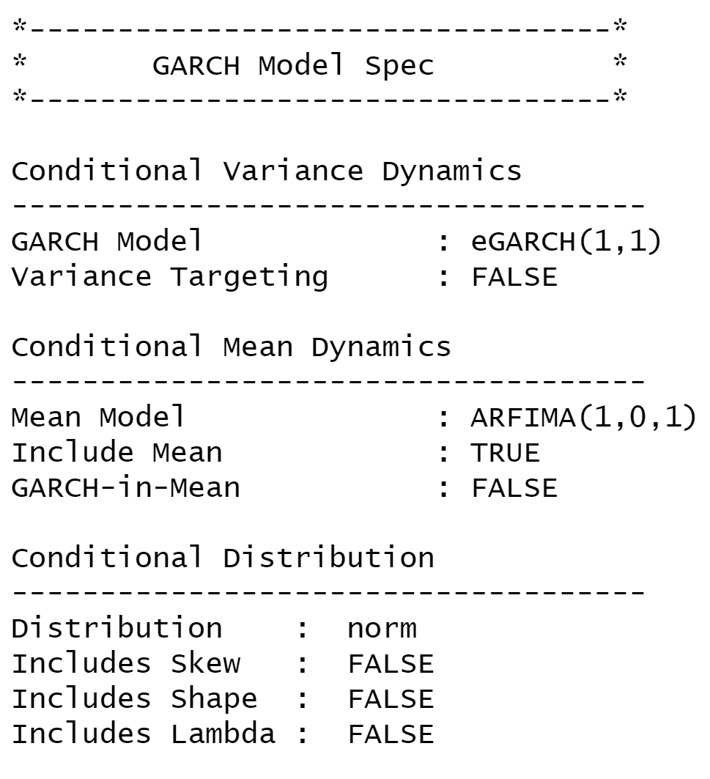

Figure 2.23: eGARCH Specs for Weekly Returns of BERGEPAINT

From above table we see that EGARCH (1,1) is the most appropriate model and by default the mean model ARFIMA (1,0,1) is chosen. These results are similar to what we observed for GARCH model.

**Estimating the model:**

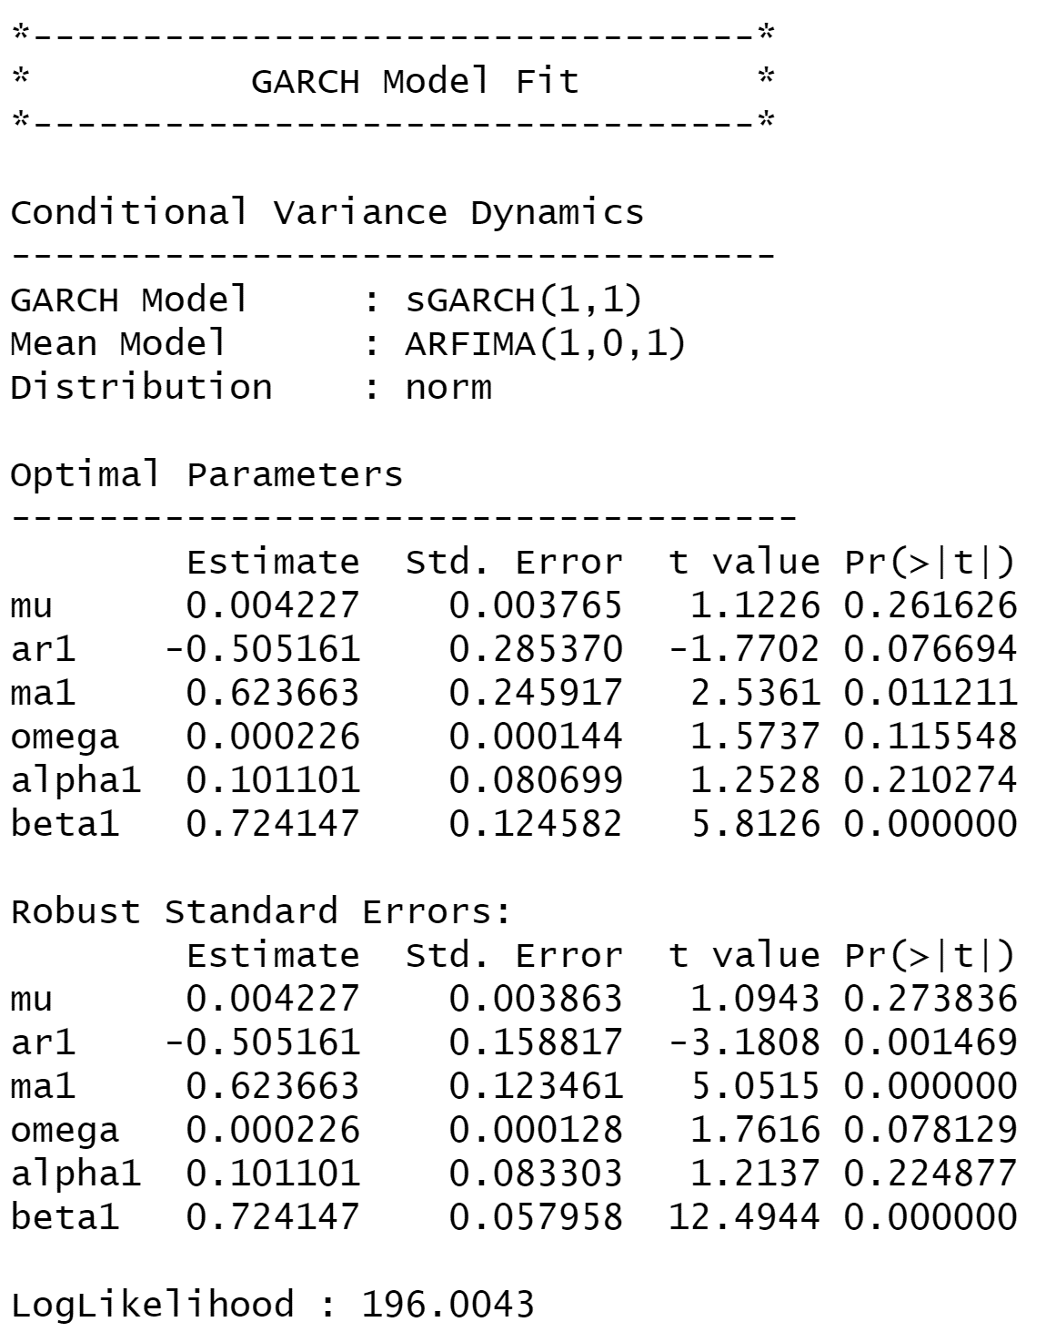

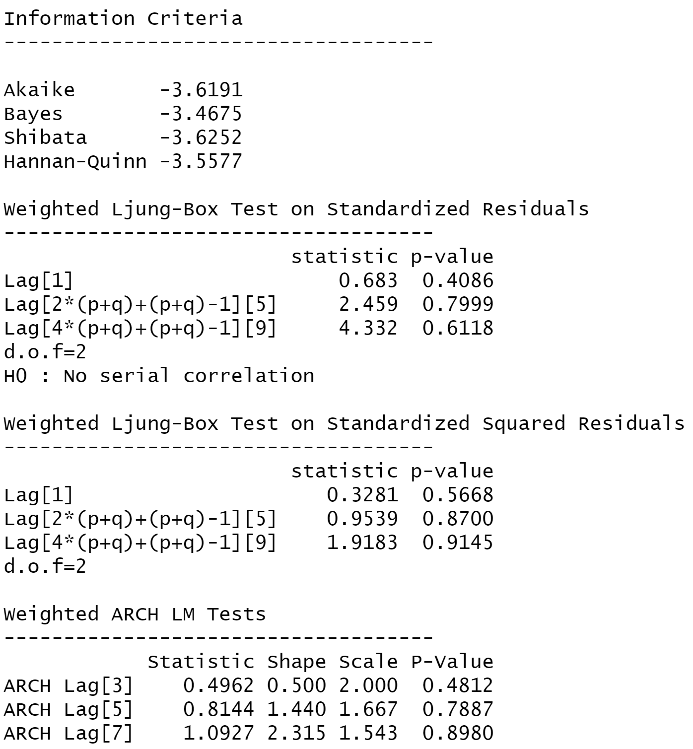

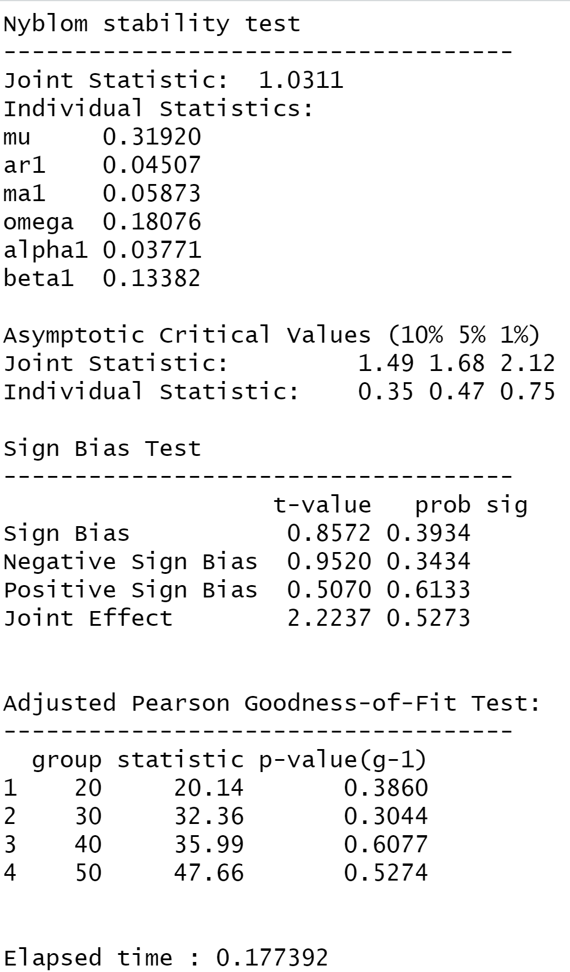

figure 2.24: Diagnostic Test of GARCH Model for Weekly Returns of BERGEPAINT

**Interpretation:**

* In GARCH, the variance tends to show mean reversion which means it gets pulled to a long-term volatility rate over time.
* Here Omega, Alpha and Beta are obtained from estimated standard error are given in the figure above.

**GARCH Model Forecast:**

Now we use the GARCH Model to forecast volatility after 31st March, 2022. The forecast obtained was as follows.

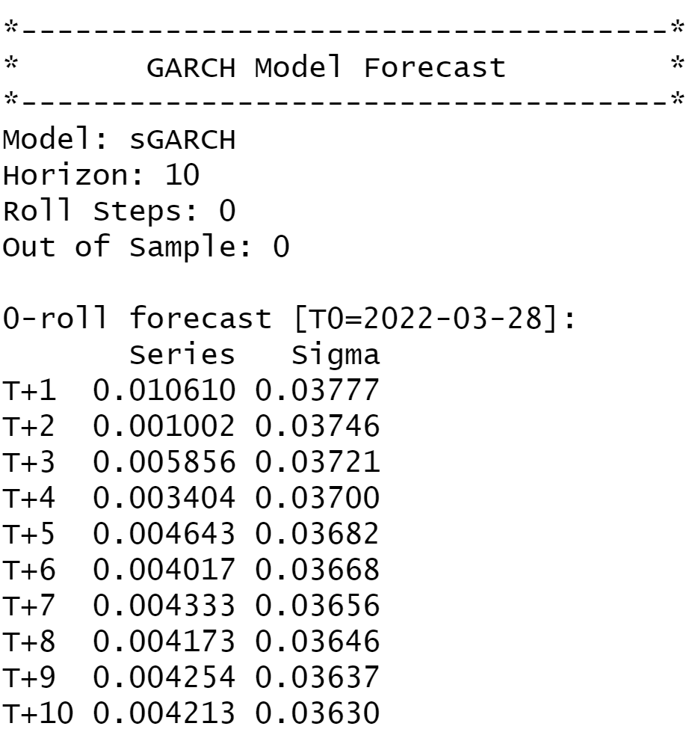

Figure 2.25: Forecasted Volatility of Weekly Returns of BERGEPAINT

## Monthly Returns Analysis

### Estimating Beta using CAPM Model

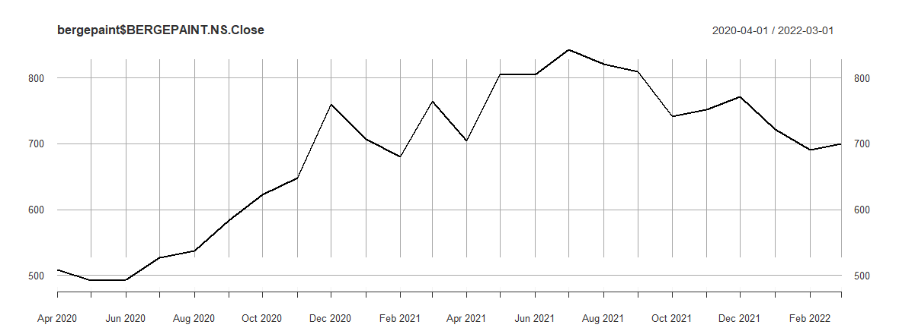

figure 2.26: Monthly Closing Price of BERGEPAINT vs Date

Returns of the security was again observed for further analysis, however, no specific pattern was observed from the plot as the returns usually kept oscillating in the range of -5% to 15% with some days having returns more than 15% and less than -5%.

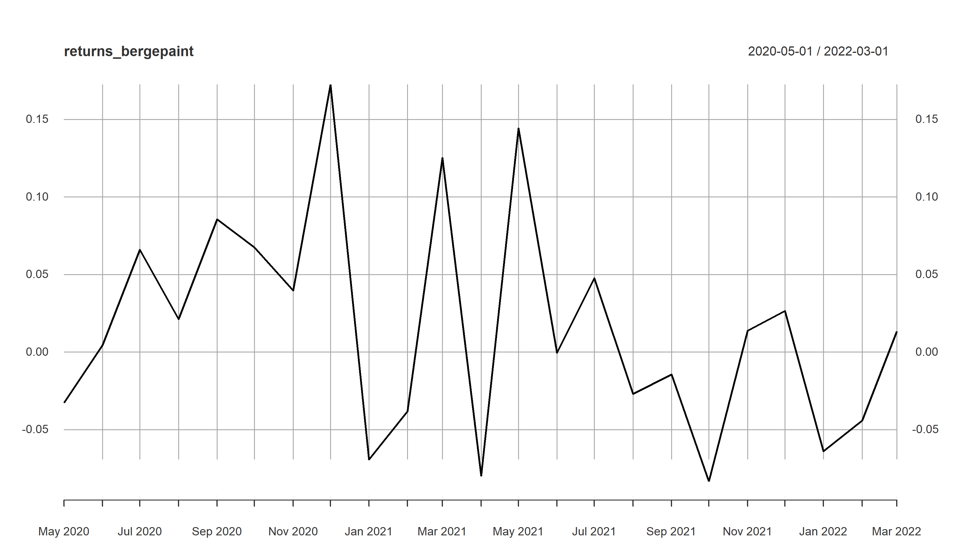

figure 2.27: Monthly Returns of BERGEPAINT vs Date

The excess monthly returns are regressed as the dependent variable with the excess market returns as the independent variable.

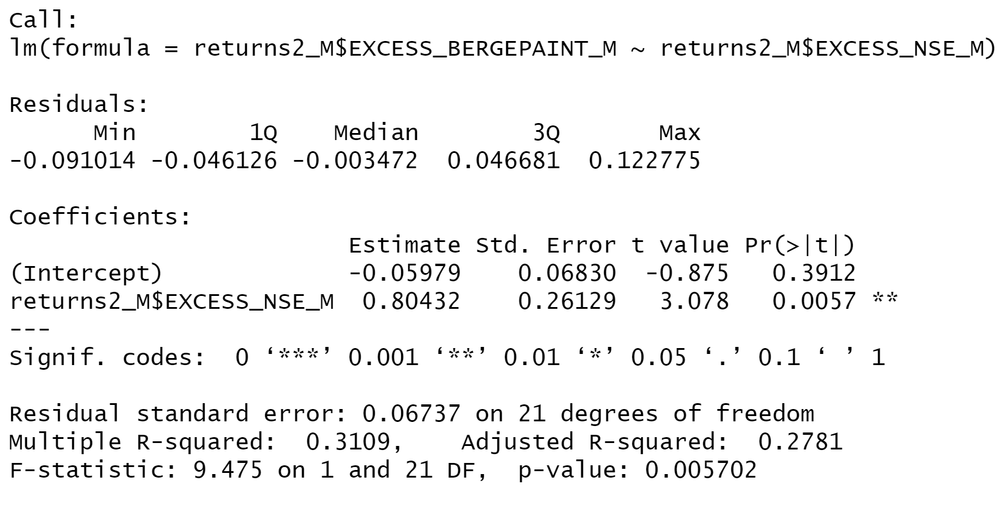

Figure 2.28: Results of Linear Regression for Monthly Returns of BERGEPAINT

Based on the results from the CAPM we can see that the slope of regressed line is 0.80432 with an intercept of 0.05979. The p value for the slope being less than 0.05 indicating that the regression has a confidence interval of 95%.

**Economic Interpretation**: Beta of the regression was found out to be 0.8 which indicates that the security is less sensitive to changes in macroeconomic factors than the market. For a change of 1% in market return the security return will change by 0.8%.

### Estimating AR and MA coefficients using ARIMA Model

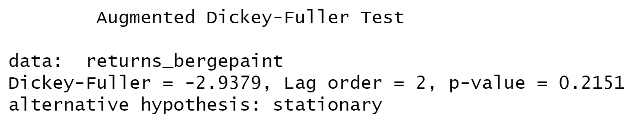

Figure 2.29: Augmented Dickey-Fuller Test for Weekly Returns of BERGEPAINT

**ACF Plot:**

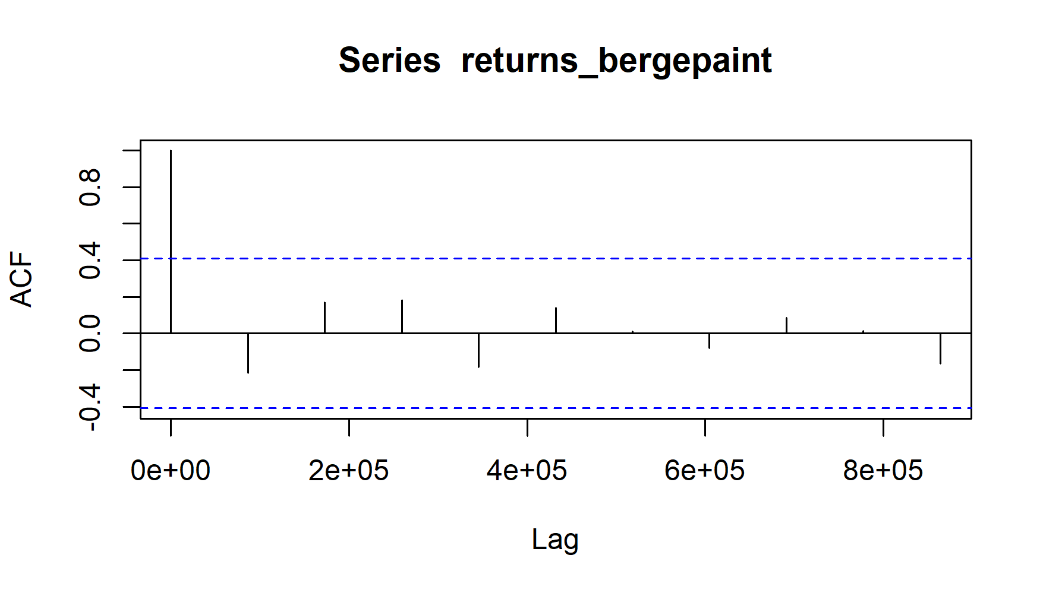

Figure 2.30: ACF Plot for Monthly Returns of BERGEPAINT

The ACF property gives a distinct pattern for the autocorrelations. For a positive value of ϕ1, as the lag h increases, the ACF will exponentially decrease to 0 whereas for negative ϕ1 the ACF exponentially decays to 0 as the lag increases.

As the ACF is significant for 2 values of lag, the order of the MA would be 2. Hence, it is estimated to be a MA(2) model.

**PACF Plot:**

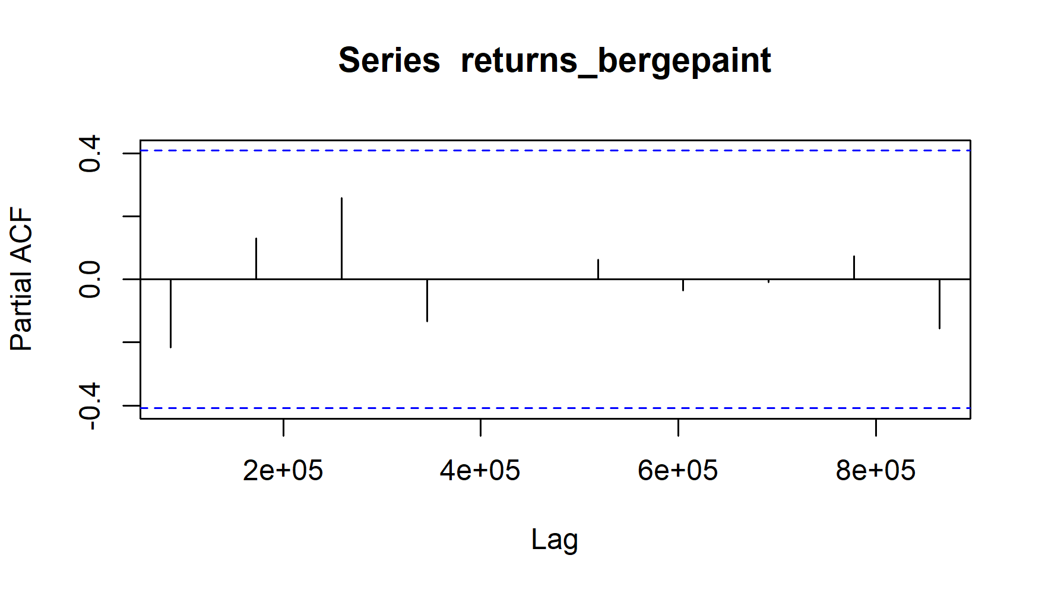

Figure 2.31: PACF Plot for Monthly Returns of BERGEPAINT

Autocorrelation for all the lags are statistically unsignificant. This suggests a possible AR (0) model for these data. As can be seen from the graph above that the PACF is not significant for any value of lag, the order of the auto regressive model can be taken as zero

After this, we run the ARIMA model on all orders (p,d,q) which we think might make a good model and choose the best amongst them. The best model is that which have the least AIC value. Using the ARIMA model, we predict the values for a small period of time and assess the model finally.

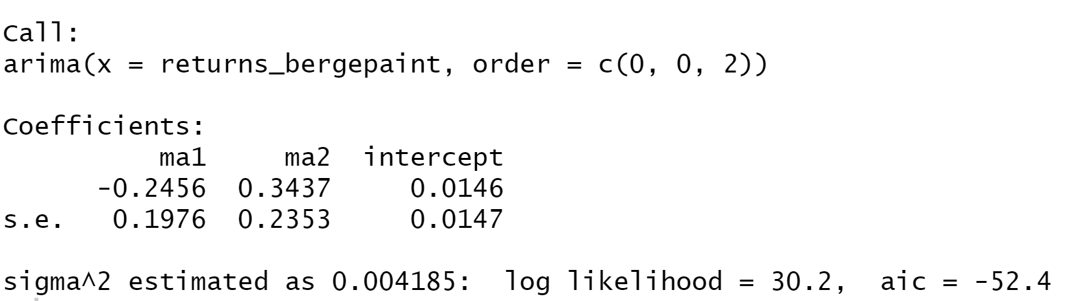

After running various (p,d,q) models we see that the least value of AIC is for the (0,0,2) which is what we estimated from ACF and PACF models.

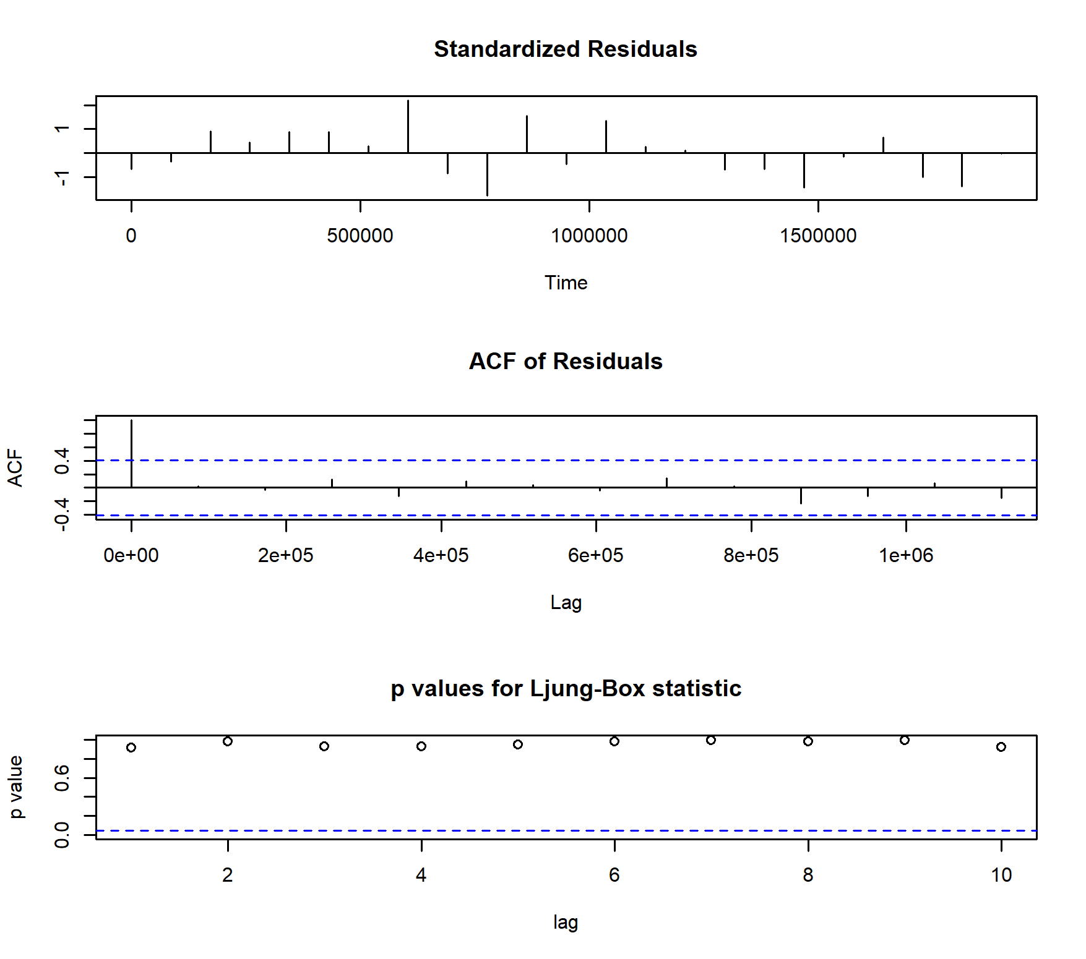

Figure 2.32: ARIMA Model Test for Monthly Returns

**Prediction using the ARIMA model:**

The ARIMA Model was used to predict the return after the analysis period which end on 31 March, 2022. The forecast given by the model is given below.

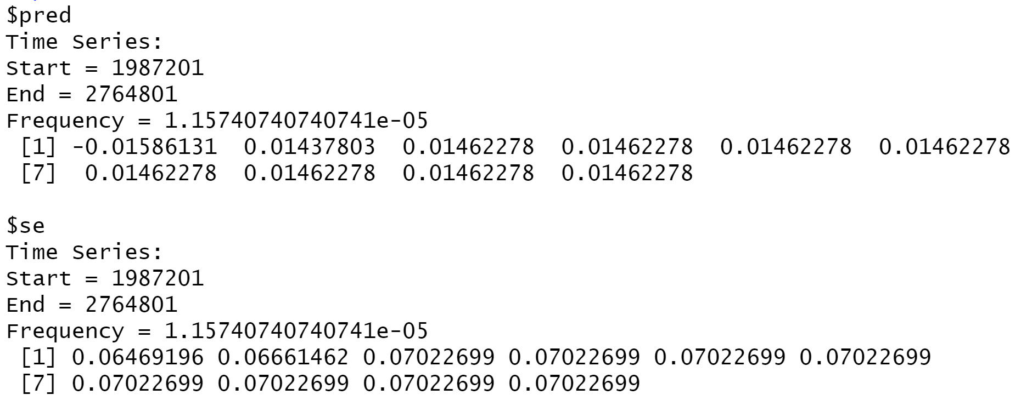

Figure 2.33: Forecasted Returns of BERGEPAINT using ARIMA Model

### Forecasting volatility using GARCH and EGARCH Models

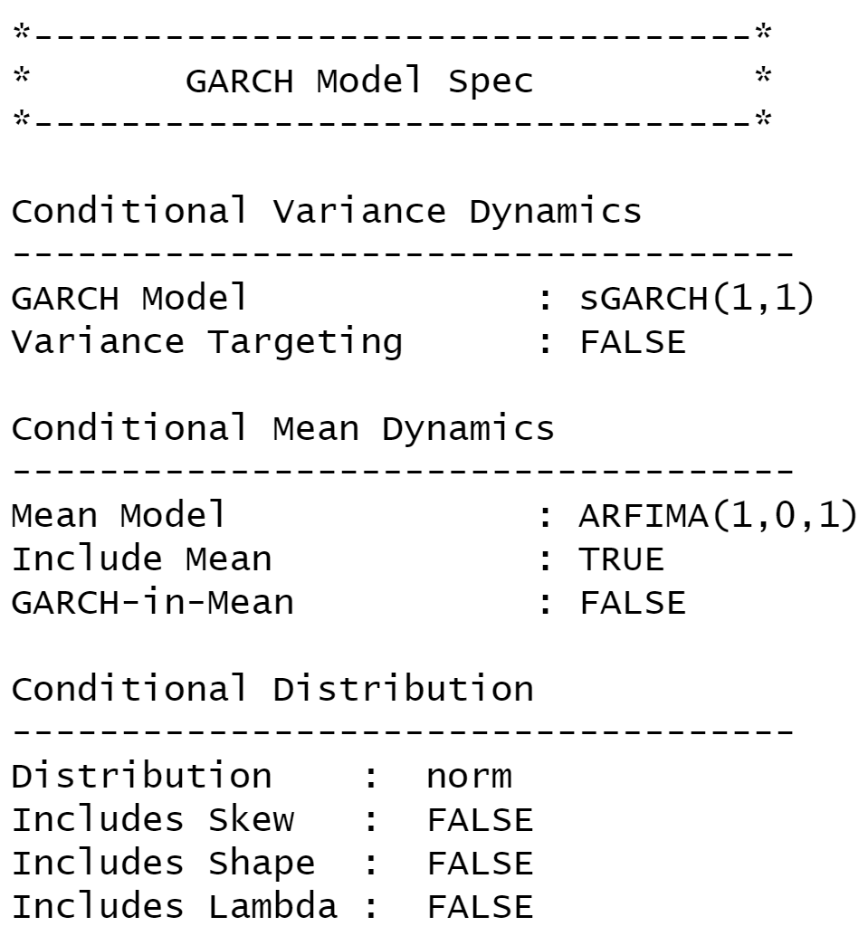

Figure 2.34: GARCH Specs for Monthly Returns of BERGEPAINT

From above table we see that GARCH (1,1) is the most appropriate model and by default the mean model ARFIMA (1,0,1) is chosen.

We run the EGARCH models again on the monthly returns of BERGEPAINT

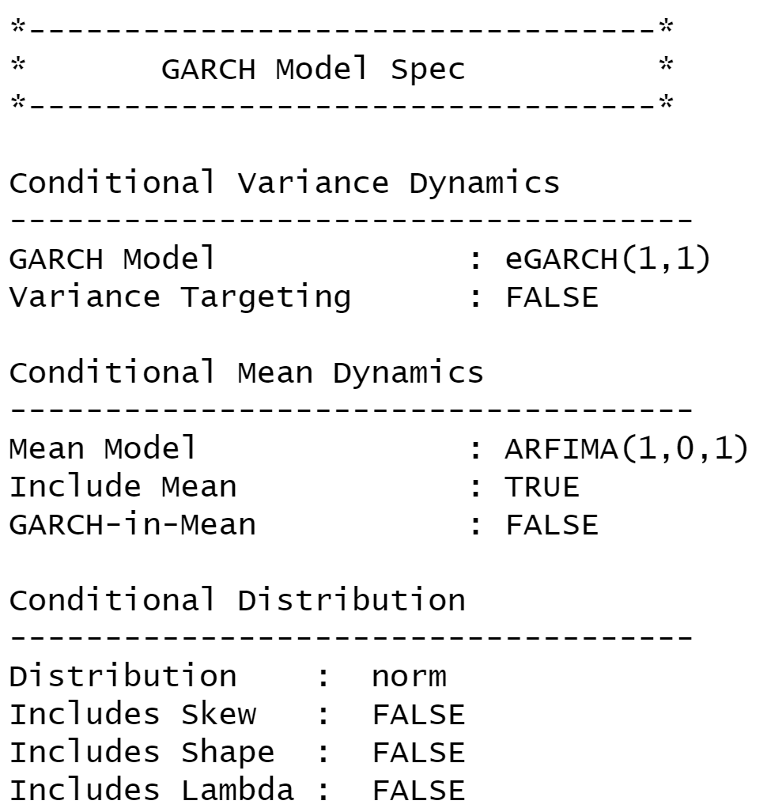

Figure 2.35: GARCH Specs for Monthly Returns of BERGEPAINT

From above table we see that EGARCH (1,1) is the most appropriate model and by default the mean model ARFIMA (1,0,1) is chosen. These results are similar to what we observed for GARCH model.

**Estimating the model:**

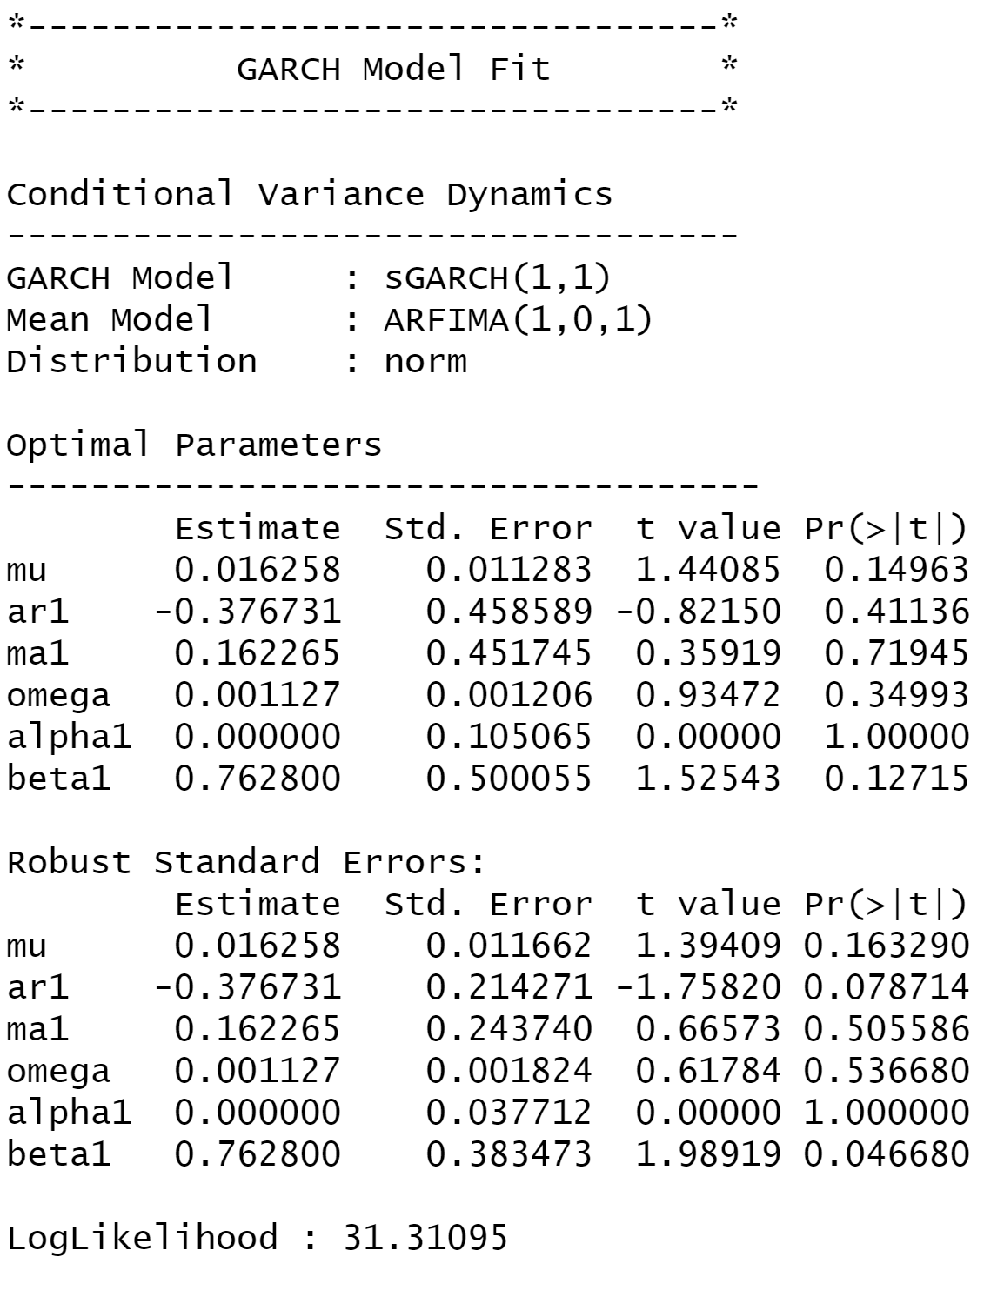

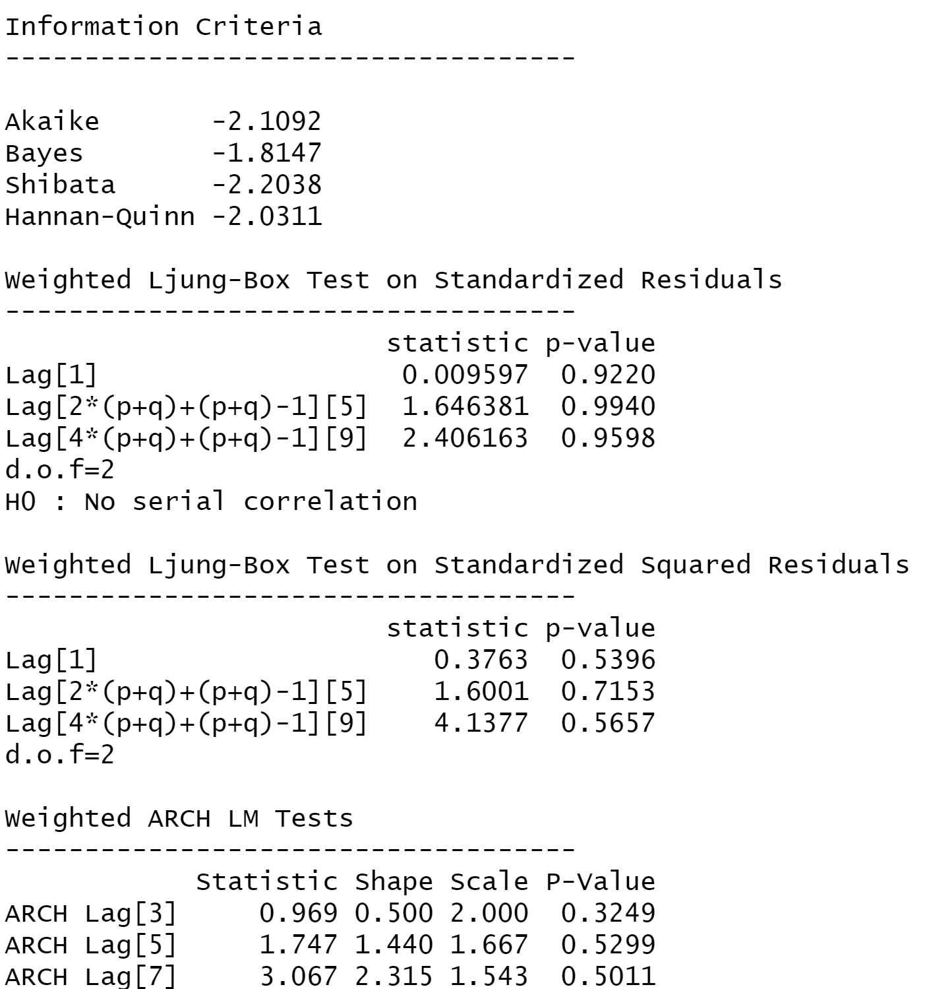

figure 2.36: Diagnostic Test of GARCH Model for Monthly Returns of BERGEPAINT

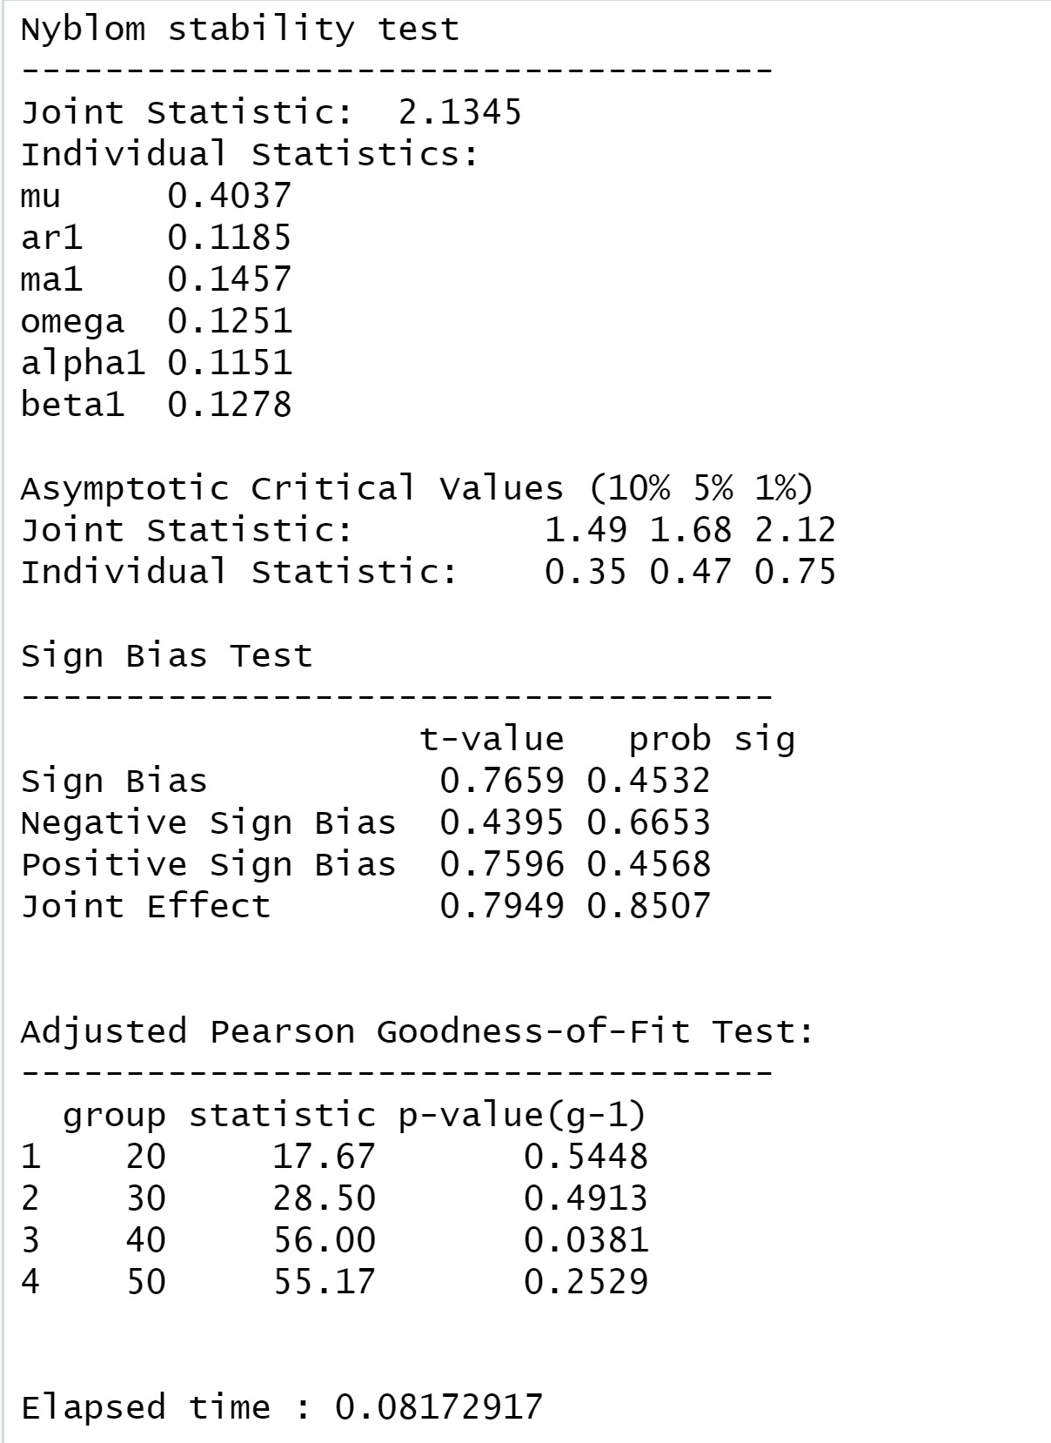

**Interpretation:**

* In GARCH, the variance tends to show mean reversion which means it gets pulled to a long-term volatility rate over time.
* Here Omega, Alpha and Beta are obtained from estimated standard error are given in the figure above.

**GARCH Model Forecast:**

Now we use the GARCH Model to forecast volatility after 31st March, 2022. The forecast obtained was as follows.

## Conclusion

* The beta from regression between the returns of BERGEPAINT taken as dependent variable against NIFTY 50 as independent variable was completed and the beta was obtained for daily, weekly, and monthly as 0.666, 0.738322 and 0.80432 respectively.
* ARIMA (0,0,0) model was found to be the best fit for forecasting returns in all three of the frequencies and the returns were forecasted for next 10 periods using the model itself.
* GARCH(1,1) model was also found to be the best fit to model the forecast regarding conditional volatility for all three frequencies and volatilities of the next 10 periods for BERGEPAINT was forecasted using this model.

## References

* <https://in.finance.yahoo.com/>
* [Wall Paint, Home Painting & Waterproofing in India - Berger Paints](https://www.bergerpaints.com/)
* [Bata - New Arrivals for Men, Women and Kids Online](https://www.bata.in/new/?gclid=Cj0KCQjwma6TBhDIARIsAOKuANzfXekz9fAYoZ4TFzARYd_Ce187Lqru0tZFPY13XGt7MkOkmIcpLSsaAqFIEALw_wcB)
* <https://www.moneycontrol.com>